Camp 699 Tyne J Camp, (Gosforth Camp), Gosforth, Newcastle-upon-Tyne, Northumberland

1947 Camp List
699(G.W.Coy) | N | Tyne J Camp, Gosforth, Newcastle-on-Tyne | Gosforth 51422 | 36 | V/1270/4

Prisoner of War Camps (1939 – 1948) - Project report by Roger J.C. Thomas - English Heritage 2003
OS NGR | Sheet | No. | Name & Location | County | Cond’n | Type 1945 | Comments
NZ 2560 5716 | 88 | 699 | Tyne J. Camp, Gosforth, Newcastle-upon-Tyne | Northumberland | 5 |  | Two possible camps at NZ 2520 7191 or NZ 2560 5716

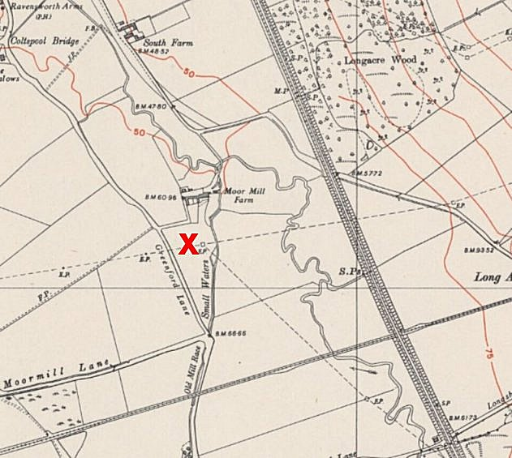 | 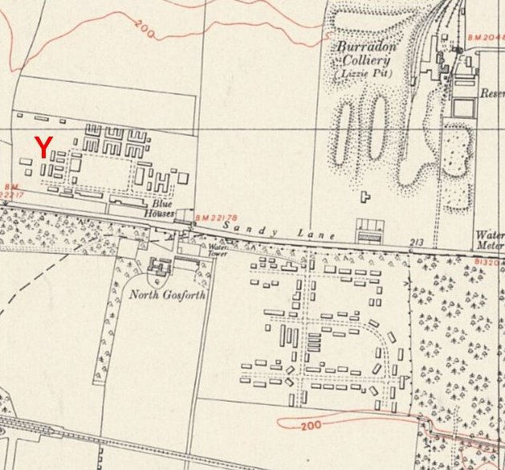 | 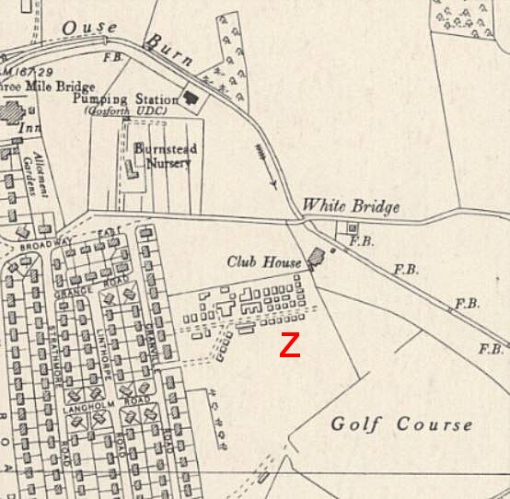
X – NZ 2560 5716 | Y – NZ 2520 7191 | Z – NZ 2470 6910
Ordnance Survey 1951

Location: English Heritage gave two NGR’s, and I have to add a possible third.
X – no sign of any camp. 12km S of Gosforth. It does not seem likely at all.
Y – A definite camp in the location. 4km NE of Gosforth.
Z – At the edge of Gosforth. The site of ‘Tyne J’ which was a Heavy Anti Aircraft Battery. (HER 5499). Apart from the name Tyne J, it was also called Gosforth Camp.

Before the camp:

Pow Camp:

Pow letter sheet August 1946.

After the camp:

Site Y - https://repatriatedlandscape.org/england/pow-sites-in-the-north-east/pow-camp-699-tyne-j/

Further Information:

Site Z - HER 5499 - Alan Rudd, 1986, List of 20th century defence sites on Tyneside; English Heritage Hadrian's Wall WHS Mapping Project, 2008, 1433708; Aerial Photograph RAF 3G/TUD/UK/94 5207 29-MAR-1946; C.S. Dobinson, 1996, Twentieth Century Fortifications in England, volume 1. Anti-aircraft artillery: England's air defence gunsites, 1914-46, page 480.

