Camp 697 Royal Artillery Practice Camp, Sennybridge, Breconshire

1947 Camp List
697(G.W.Coy) | W | R.A.Practice Camp, Sennybridge, Brecon | Sennybridge 61 Ext.26 | 29(W.O.) | V/1270/4

Prisoner of War Camps (1939 – 1948) - Project report by Roger J.C. Thomas - English Heritage 2003
OS NGR | Sheet | No. | Name & Location | County | Cond’n | Type 1945 | Comments
 |  | 697 | Royal Artillery Practice Camp, Sennybridge | Breconshire |  | German Working Camp | Wales

Location: Within large military site across the River Usk from Sennybridge. NGR for the cookhouse with pow murals - SN 920 292.  Before the camp: Sennybridge training area was requisitioned in 1939. In 1940 it became the Royal Artillery Practice Camp.  Pow Camp: Information from the Sennybridge Conservation Group -  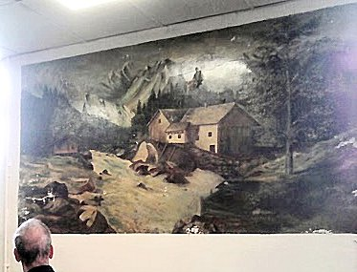  “Evidence still remains at Sennybridge of the German and Italian Prisoner of War (POW) Work Companies that were located here during and after the the Second World War. They were heavily involved in constructing range infra-structure (including roads, bridges and drainage culverts).  Three POW Work Companies were known to have been engaged at Sennybridge: ● 573 - Nationality Unknown ● 697 - German ● 731 - Italian  From the available evidence it seems that POW labour was used at Sennybridge from 1944 through to November 1946. The R.A Practice Camp, Sennybridge is recorded as having 549 POW’s on 8 September 1946 located at The Main Camp and externally in hostels. A camp was located at Cwm Owen on the far eastern side of the on the training area.” (* Booklet freely available). | 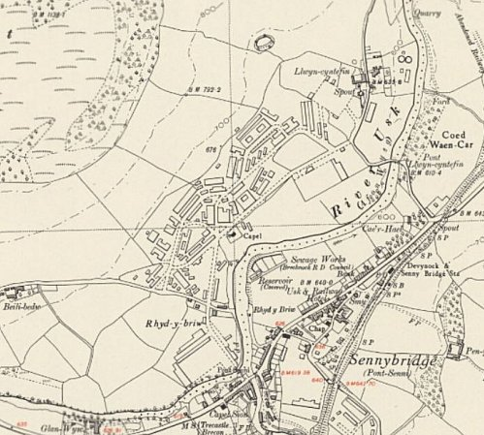
 | Ordnance Survey

The cookhouse building dates from 1940. Four murals were later painted on the walls by pows – “It has four rectangular paintings on the end and side walls, of approximately 2.1m by 0.9m. They are painted in oils on the plaster (which was later varnished) and each was surrounded by a painted frame. The first picture shows a view of Heidlberg Castle and town in southern Germany, with a multiple-arched stone bridge in the foreground leading to a town through a tall double-towered gate. The architectural details are so accurate that the scene may well have been painted from a photograph or postcard. The second is a mountain landscape with a deep lake. The third is an alpine scene of mountain farms beneath a glaciated cwm. The fourth is an alpine scene of snow-covered peaks and a fast-flowing stream with rapids. The paintings are believed to have been executed by prisoners of war, and both Italian and German prisoners worked there in 1945-6.” (Coflein – see below – includes pictures of the murals).

The photograph above was taken during the Uplands Archaeology Forum and Dayschool visit to Sennybridge in 2014 showing one of the murals
As part of the re-education programme administered by the Control Office for Germany and Austria (COGA), Paul Bondy, a German-speaking refugee gave lectures at the camp 0n 16-17 October 1946. He recorded a camp complement of 789.
After the camp:
Further Information:
National Archives – FO 939/326 – 697 Working Camp, Sennybridge Camp, Tremorgan, Pembrokeshire. Dated 1946.
* SENNYBRIDGE TRAINING AREA - Prisoner of War Infra-structure Sites / POW Working Companies at Sennybridge Survey : Sennybridge Conservation Group Mark Khan 12 October 2014 - http://www.commandpostmedia.com/Sennybridge%20POW%20Site%20Survey.pdf?LMCL=DrHWUZ

coflein.gov.uk/en/site/23191/details/sennybridge-army-camp-cookhouse-featuring-prisoner-of-war-paintings

