Camp 696 Warwick Camp, Durranhill Road, Carlisle, Cumberland

1947 Camp List
696(G.W.Coy) | W | Warwick Camp, Durranhill Road, Carlisle, Cumberland | Carlisle 879 | 65(W.O.) | V/1270/4

Prisoner of War Camps (1939 – 1948) - Project report by Roger J.C. Thomas - English Heritage 2003
OS NGR | Sheet | No. | Name & Location | County | Cond’n | Type 1945 | Comments
NY 4278 5557 | 85 | 696 | Warwick Camp, Duranhill Road, Carlisle | Cumberland | 4 | German Working Camp | Pre-existing military camp. Industrial estate.

Location: On the E edge of Carlisle  Before the camp: Golf course. Site taken over in 1939 for use as a military camp.  Pow Camp:  Postal item seen for December 1946  As part of the re-education programme administered by the Control Office for Germany and Austria (COGA), Paul Bondy, a German-speaking refugee gave lectures at the main camp and 1 hostel on 30 January and 1 February 1947. He recorded a main camp complement of 300, with 180 in the hostel.  After the camp: 2020 Rosehill Industrial Estate.  Further Information: | 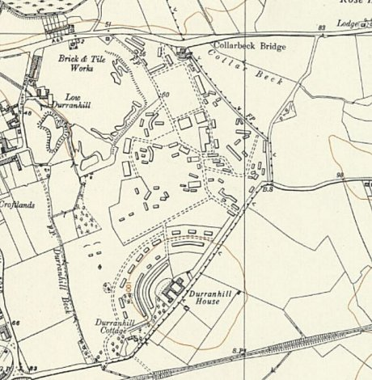
 | Ordnance Survey 1957

