Camp 695 Borgard Barracks, Shrivenham, Wiltshire (aka Horgard)

1947 Camp List
695(G.W.Coy) | S | Borgard Barracks, Shrivenham, Nr.Swindon, Wilts | Swindon Trunks 17 Ext.1 | 52(W.O.) | V/1270/4

Prisoner of War Camps (1939 – 1948) - Project report by Roger J.C. Thomas - English Heritage 2003
OS NGR | Sheet | No. | Name & Location | County | Cond’n | Type 1945 | Comments
SU 2546 9067 | 174 | 695 | Horgard Barracks, Shrivenham | Oxfordshire | 4 | German Working Camp | Camp comprising some 120 bell tents within an irregular fenced compound guarded by watchtowers. Housing and vehicle park.

Borgard / Horgard? I believe the correct name for the camp was Borgard – though many sources list Horgard.  I believe it was named after Albert Borgard a Colonel of the Royal Artillery in 1716. Contemporary documents include the 1947 list above and a record of a marriage – ‘George Mawson - 29 Gunner R.A. Bachelor of Borgard Barracks, Shrivenham, Berks.’  A history of the Royal Militray College states – “The two buildings that were to administer the regiments were the first to be built and were called ‘Watson’ and ‘Borgard’ later to become Roberts and Kitchener Halls.” (Neil Maw on:  http://www.whereitis.co.uk/watchfield.chronicle/key-page/the-military-college.html - also * below).  I can not find any contemporary references to Horgard. All entries referring to Horgard seem to appear after the English Heritage listing above, which I think was a basic spelling error.  Location: On the edge of the village of Watchfield. Marked X on map.  Before the camp:  Pow Camp: * “There was also a Prisoner of War Camp for captured Germans which was the traditional square shape with the four guard towers on each corner. Its location was where the old guard room stands just west of the present day entrance roundabout. (Grid ref SU 2525 9045). Mrs Maureen Coyle remembers that many of the Prisoners were employed keeping the local roads clear. She also recalls that during one Christmas, families living in the army quarters were permitted to entertain two prisoners and that some of them made beautiful wooden toys for the children.”  Postal item seen from 2 May 1947. | 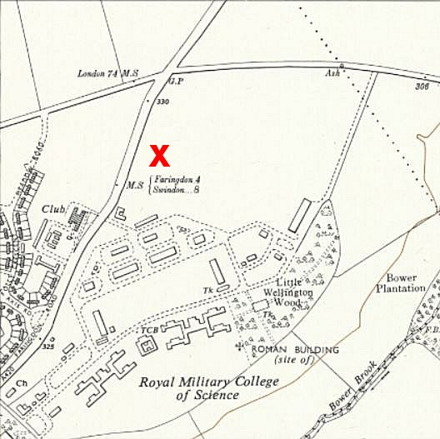
 | Ordnance Survey 1961
After the camp:
Further Information:

