Camp 694 Handy Cross Camp, Bideford, Devon

1947 Camp List
694(G.W.Coy) | S | Handy Cross Camp, Bideford, Devon | Bideford 605 | 37(W.O.) | V/1270/4

Prisoner of War Camps (1939 – 1948) - Project report by Roger J.C. Thomas - English Heritage 2003
OS NGR | Sheet | No. | Name & Location | County | Cond’n | Type 1945 | Comments
SS 4411 2587 | 180 | 694 | Handy Cross Camp, Bideford | Devon | 4 | German Working Camp | Pre-existing military camp.

Location: NGR above marked on map. The ‘bidefordbuzz’ website places the camp across the road at Pridham Place, just off Stucley Road and just N of Clovely Road. Other suggestions have been made that the site was just S of Clovely Road.  Before the camp: US troops had various camps in Bideford and in the Handy Cross / Bowden Green area. The site had barrack huts and a cinema.  Pow Camp: Established in the US army camp after D-day.  After the camp:  https://repatriatedlandscape.org/england/pow-sites-in-the-south-west/pow-camp-694-handy-cross/  Further Information:  National Archives 939/325 – listed as 994 [I think this is an error for 694] Working Camp, Handy Cross Camp, Bideford, Devon. Dated 1946 - 1947.  Camp visible on aerial photograph Royal Air Force SDV342938 | 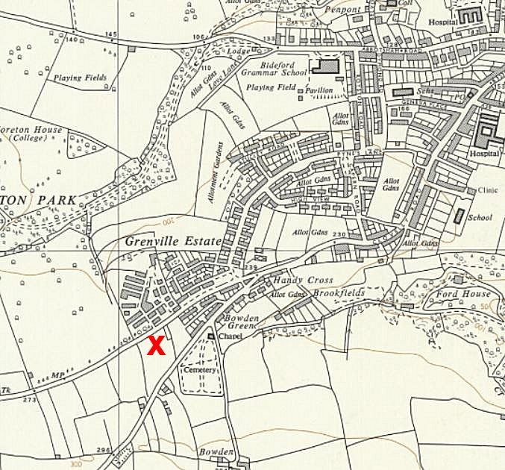
 | Ordnance Survey 1963

