Camp 693a Whitchurch Camp, Newbury Road, Whitchurch, Hampshire

Prisoner of War Camps (1939 – 1948) - Project report by Roger J.C. Thomas - English Heritage 2003
OS NGR | Sheet | No. | Name & Location | County | Cond’n | Type 1945 | Comments
SU 4641 4872 | 185 | 693a | Whitchurch Camp, Newbury Road,  Whitchurch | Hampshire | 3 | German  Working Camp | PoW hostel. Site within modern  housing, possibility of some remaining features.

Location: North edge of Whitchurch  Before the camp:  Pow Camp:  The English Heritage report states that this was a hostel. It may have been linked to camp 652 / 693 Durnells Farm which is about 44km N of the Whitchurch site.  After the camp:  https://www.systonimages.co.uk/p514556210  Further Information: | 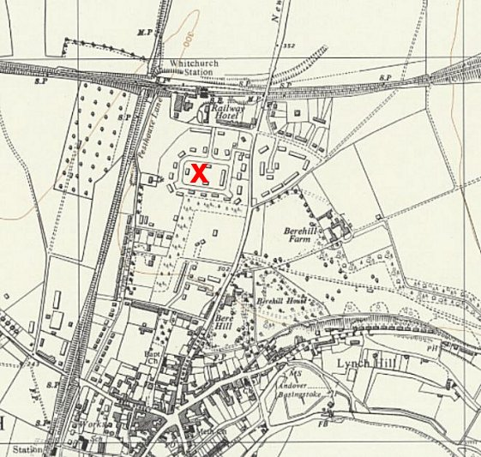
 | Ordnance Survey 1961

