**Camp 692** **No 4 Camp, Longtown, Carlisle, Cumberland**

|  |  |  |  |  |  |  |  |
| --- | --- | --- | --- | --- | --- | --- | --- |
| **Prisoner of War Camps (1939 – 1948) - Project report by Roger J.C. Thomas - English Heritage 2003** | | | | | | | |
| OS NGR | Sheet | No. | Name & Location | County | Cond’n | Type 1945 | Comments |
| NY 37 68 | 85 | 692 | No.4 Camp, Longton, Carlisle | Cumberland | 5 | German Working Camp | Precise location not identified. There are a number of candidate camps. |

|  |  |
| --- | --- |
| **Location:** The NGR given above is for a general area. Maps from the 1950’s show a number of camps around the area that I have marked X on the map. There are also brief mentions of the camp being at Hallburn in the area marked Y. Another reference mentions Hornick Hill which is at NGR NY 3761 6580 (and close to Hall Burn).  **Before the camp:** Many different ammunition storage depots and military camps were in the location which makes it difficult to identify the particular camp(s) used for pows.  **Pow Camp:** German and Ukrainian pows recorded at the camp. Pows mainly worked at local farms or in the saw mill.  Some Ukrainians who fought with the German Waffen-SS Division Galizien were brought to this camp from a camp in Rimini in 1947. The division was accused of major war crimes against civilians.  As part of the re-education programme administered by the Control Office for Germany and Austria (COGA), Paul Bondy, a German-speaking refugee gave lectures at the camp on 31 January 1947. He recorded a camp complement of 600.  A grave in Carlisle (Dalston Road) is marked for a pow from Longtown. Details from rootschat.com gives: “*The 2 graves in the photo are listed. Joachim Haase is listed as a captain and a POW. Egon Voigtmann is listed as a working man…. Egon Voigtmann drowned due to accidental drowning in the River Esk*, *near Kirkandrews. He was a POW, but it is likely he was working on a farm in the area, hence his ‘rank’ in German records as labourer. The POW camp* is recorded as 15 August 1947. |  |
| Ordnance Survey |

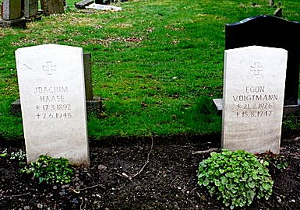[There is a similar story for a ‘Hinz Siegfried’, who apparently also drowned in the River Esk, in August 1946 – I have found no further details and it seems a strange coincidence].

**After the camp:** Possibly Polish displaced persons camp.

**Further Information:**