Camp 689 Blackmore Camp, Great Malvern, Worcester, Worcestershire

1947 Camp List
689(G.W.Coy) | W | Blackmore, Malvern, Worcester. (Postal Address) 689 P.W.W. Coy.Blackmore II Camp, Nr.Gt.Malvern, Worcestershire | Malvern 1122 | 25(W.O.) | V/1270/4

Prisoner of War Camps (1939 – 1948) - Project report by Roger J.C. Thomas - English Heritage 2003
OS NGR | Sheet | No. | Name & Location | County | Cond’n | Type 1945 | Comments
SO 7983 4353 | 150 | 689 | Blackmore Camp, Blackmore Park, Great Malvern | Worcestershire | 3 | German Working Camp

Location: The NGR is for the camp area just above Lower Arles Wood.  Before the camp: Military camp. Two US hospital units were based at Blackmore Park until September 1945.  Pow Camp: German Working Camp.  After the camp: The ‘Traces of War’ website records that – “After the war, the water towers and a number of huts remained until the present day.” 2020 Industrial estate.  Further Information:  Air photographs - RAF 106G/UK/1354 7254-6 02-APR-1946 and  106G/UK/1652 4337-8 11-JUL-1946  For US Hospitals at the site see –  Blackmore Park in World War Two – An account of the US Army hospitals at Blackmore Park, Malvern 1943-5 : F and M Collins : Brewin Books : 2008 | 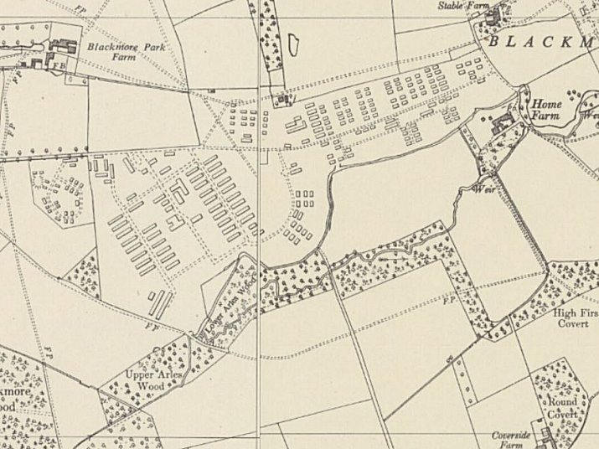
 | Ordnance Survey 1955

