Camp 688 Park Camp, Lulworth Cove, West Lulworth, Dorset

1947 Camp List
688(G.W.Coy) | S | Park Camp, Lulworth Cove, Dorset | West Lulworth 24 | 37(W.O.) | V/1270/4

Prisoner of War Camps (1939 – 1948) - Project report by Roger J.C. Thomas - English Heritage 2003
OS NGR | Sheet | No. | Name & Location | County | Cond’n | Type 1945 | Comments
SY 846 820 | 194 | 688 | Park Camp, West Lulworth | Dorset | 4 | German Working Camp | Former British Army camp within woodland.

Location: Park land to the W of Lulworth castle. Questions have been raised about the location of this camp – or whether it was at Lulworth Cove – or possibly both sites as linked camps.  Before the camp:  Pow Camp: “Situated between West Lulworth and East Lulworth, this was a camp with around 100 huts. The ‘high’ number of 688, shows this was a late camp – opened for PoWs at the end of the war. It housed German PoWs who took over an existing British Army camp. It was still in existence in the 1950’s for Displaced Persons”. [Information from Pete Wood - ww2talk.com/ ]  After the camp: Area shown as cleared on 2020 OS map.  https://repatriatedlandscape.org/england/pow-sites-in-the-south-west/pow-camp-688-park-camp/  Further Information: | 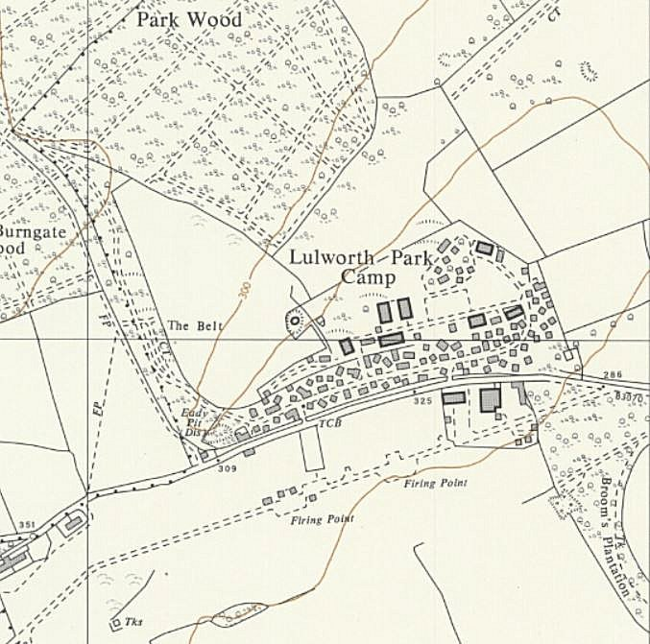
 | Ordnance Survey 1963

