Camp 686 Moreton-on-Lugg, Hereford, Herefordshire

1947 Camp List
686(G.W.Coy) | W | 42 O.S.D. Moreton-on-Lugg, Hereford | Hereford 2576 Ext.25 or 35 | 29(W.O.) | V/1270/4

Prisoner of War Camps (1939 – 1948) - Project report by Roger J.C. Thomas - English Heritage 2003
OS NGR | Sheet | No. | Name & Location | County | Cond’n | Type 1945 | Comments
SO 5018 4601 | 149 | 686 | German Prisoner Working Camp (GPW Coy.), Moreton-on-Lugg | Herefordshire | 4 | German Working Camp | Housing and farmland.

Location: About 6km N of Hereford.  Before the camp:  Pow Camp:  After the camp:  Further Information:  National Archives – FO 939/324 - 686 Working Camp, Moreton-on-Lugg Camp, Hereford. Dated 1946 - 1947 | 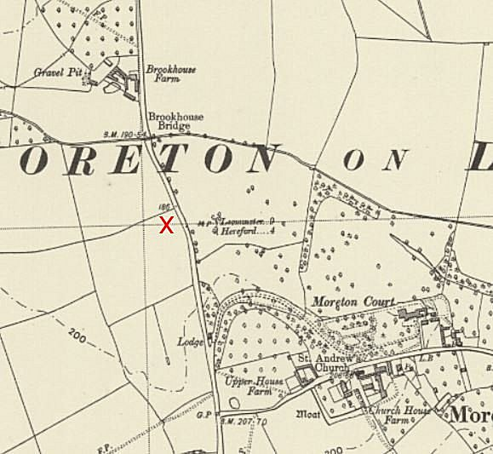
 | Ordnance Survey

