Camp 678 Fort Crosby, Hightown, Lancashire

1947 Camp List
678(G.W.Coy) | W | Fort Crosby, Hightown, Nr.Liverpool, Lancs | Hightown 192 | 65(W.O.) | V/1456/2

Prisoner of War Camps (1939 – 1948) - Project report by Roger J.C. Thomas - English Heritage 2003
OS NGR | Sheet | No. | Name & Location | County | Cond’n | Type 1945 | Comments
SD 296 025 | 108 | 678 | Fort Crosby, Sniggery Farm, Hightown | Lancashire (Merseyside) | 4 | German Working Camp | Camp associated with former coast artillery battery & heavy anti-aircraft battery. Sand dunes.

Location: About 6km N of Crosby. Alongside Sniggery Farm, (sniggeries were eel ponds).  Before the camp: Fort Crosby was started in 1906. The site was surrounded by high, barbed wire fences. The accommodation camp (Sniggery Barracks) for soldiers was across the railway on land belonging to Sniggery Farm.  Pow Camp: “The camp at Fort Crosby was adapted from an existing installation and was situated at the western end of the road leading from the main entrance (now adjacent to the railway). Fort Crosby was used as a camp for a German Working Company and also housed working Italian PoWs from 1945 until 1950. [After 1948 the camp was no longer classed as a pow camp.]  Prisoners were housed in wooden huts, each accommodating 20 men. They were situated adjacent to the football field at Fort Crosby and were separated from the fort by a barbed wire fence and a guarded gateway.  Some prisoners were soldiers who became displaced people towards the end of the war due to political changes at home. Unable to return home, they lived at the camp for some time before being resettled. They were guarded by Polish soldiers, who had their own accommodation on the site, to the south west of the prisoners’ huts. The area of hard standing to the front of these buildings can still be traced in the tarmac that remains on site. As a working camp, prisoners were engaged in construction projects and worked at local farms, returning to the camp at night.  In their spare time, the PoWs played sports and made toys which they sold from a small hut near the station at Hightown. The camp also had a cinema, open to both prisoners and non-residents of the camp, which showed German films on a Tuesday night and English films on a Thursday. The films shown were very popular and were well attended by local people, who walked to the fort from both Hightown and Crosby.” | 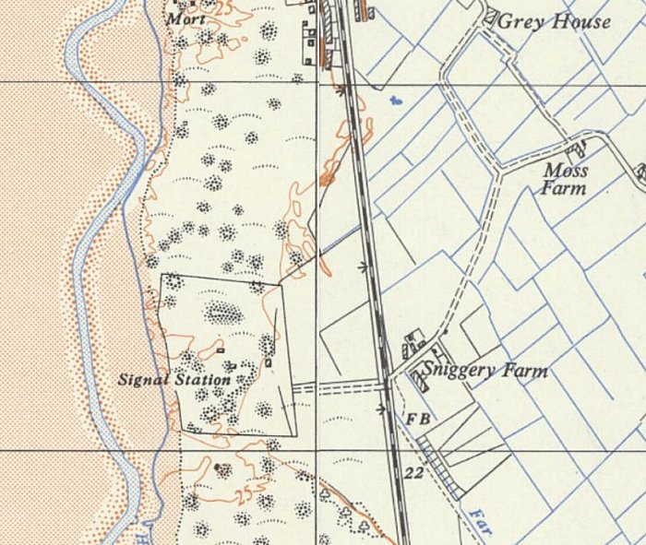
 | Ordnance Survey 1957
Extract - See Alison Burns’ book; link below.
The footballing legend, Bert Trautmann, was a pow for a short time at this camp.
Closed 1948

After the camp: From 1950 to 1954 used by the Territorial Army. The Fort closed in 1957. Demolished 1967.

Further Information:
Fort Crosby: Dune Heritage Revealed – Alison Burns - Sefton Coast Landscape Partnership – 2015 – available from: www.academia.edu/17314554/Forgotten_Fort_Crosby_Dune_Heritage_Revealed

https://repatriatedlandscape.org/england/pow-sites-in-the-north-west/pow-camp-678-fort-crosby/

