Camp 675 Hiltingbury Road, Chandler's Ford, Eastleigh, Hampshire

Prisoner of War Camps (1939 – 1948) - Project report by Roger J.C. Thomas - English Heritage 2003
OS NGR | Sheet | No. | Name & Location | County | Cond’n | Type 1945 | Comments
SU 4289 1887 | 185 | 675 | Hiltingury Road, Chandler's Ford, Eastleigh | Hampshire | 4 |  | Industrial area.

Note - The English Heritage entry is confusing. There is a Hiltingbury Road, and there was a camp there. However, the NGR given is NOT for that site, but another location about 3.5km SW, and there was another camp there.

Locations:

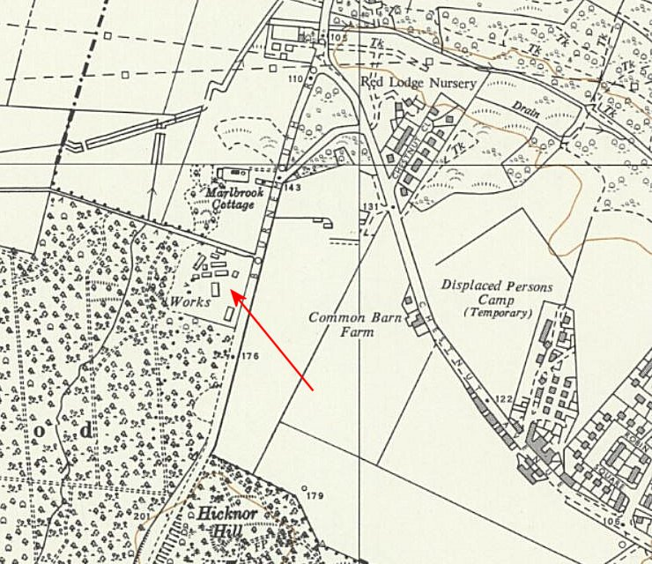 |  | 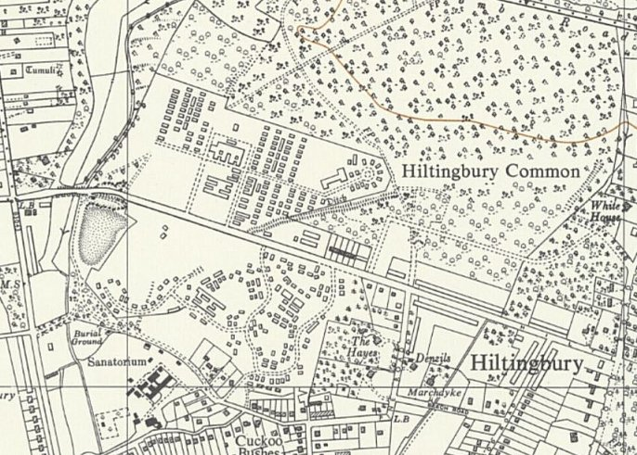
OS 1963 - The NGR – also note Displaced Persons Camp alongside |  | OS 1963 – Hiltingbury Road

Both sites had British military camps in the area – a US camp was also located just N of the NGR site at the corner of Leigh Road / Bournemouth Road.

Some details from https://chandlersfordtoday.co.uk/hutments/ : Chestnut Avenue is where the Displaced Persons Camp was located.

“I vividly remember the Polish camps in Chestnut Avenue and Hiltingbury Road. The Nissen huts with their half cylindrical shape were very distinctive.

The Polish boys in Chestnut Avenue were always up for a scrap. I can’t really remember the German PoW camp opposite the Polish camp in Hiltingbury Road but my mother talked about it. She came from Lurgan in Co. Down, N. Ireland and a soldier who was a guard at the camp came from the same town. She knew him from college days. His name was Bobby Harrison. He told a story of a German prisoner who built a most amazing ship out of matchsticks, spent many months doing it, then, in a fit of extreme anger and frustration, smashed it to pieces with his fist. That story always stuck with me.”

Another entry:

“I remember, at the age of 10, helping to fill American Jerricans with petrol at Candler’s, the local Garage (Service Station) in Bournemouth Road near Leigh Road (later to become Rowle’s) and load on to American Left Hand Drive trucks for transporting to an American Supply Depot which had been set up about ½ mile away on ‘Hut Hill’ opposite the then Limmer and Trinidad Lake Ashphalt Company, approximately where ASDA now is. [This is the NGR site]

The site of this supply depot has also been an American field hospital in 1944, an Italian Prisoner of War Camp and finally a German P.O.W. Camp.

The Italians became known, and respected, for their hard work in the community, because after Italy had capitulated, they were allowed out to carry out gardening and other jobs in various homes throughout the village … some of them remained after the War and became part of the community.”

And:

“Like other German (and Italian) prisoners-of-war in Britain, those prisoners who had been housed in two large, closely-guarded camps in Chandler’s Ford after their surrender, did not immediately return to their country after the war ended. They had to help local farmers with tending the livestock and crops, or do other work, such as in forestry and cleaning out rivers, which had been neglected during the war while British workmen had been away serving in the armed forces. It would be several years before most of the prisoners of war were sent back to Germany from Chandler’s Ford, but a few got married to local girls and settled here.”

A request for clarification about there being two camps brought this response from Doug Clews:

“There certainly was a Camp in Hiltingbury Road, opposite what was the Polish Dependants Hostel, and, at one point in its life, was used as a POW Camp.

The one the grid reference points to was on Hut Hill, opposite Limmer and Trinidad (as it was then) and roughly where ASDA now is. It started life, I think, as the 46th. American Field Hospital in 1944, and then an American Supply Depot prior to D-day, later becoming an Italian POW Camp, followed by a German one.
From memory, entry was off Chestnut Avenue, and I believe it is officially listed as being in Eastleigh, not Chandler’s Ford. Although living in Chandler’s Ford at that time, I cannot remember the actual years it was ‘which’ I am afraid.”

After the war, the site at Hiltingbury Road with huts shown to the S of the road, became a Polish Resettlement Camp.

