Camp 674 / 675 / 1016 Old Dean Common Camp, Camberley, Bagshot, Surrey

1947 Camp List
675(G.W.Coy) | S | Old Dean Common Camp, Camberley, Surrey | Camberley 155 | 30(W.O.) | V/1270/4
1016(G.Wkg.Coy) | S | Old Dean Common, Camberley, Surrey | Camberley 1154 | 30 | V/1270/4

Prisoner of War Camps (1939 – 1948) - Project report by Roger J.C. Thomas - English Heritage 2003
OS NGR | Sheet | No. | Name & Location | County | Cond’n | Type 1945 | Comments
SU 8849 6173 | 175 | 674 / 675 | Old Dean Common Camp, Camberley, Bagshot | Surrey | 4 | German Working Camp | Site occupied by housing.
SU 8837 6218 |  | 1016 |  |  | 5 |  | Precise location not identified. NGR for Common

NOTE – the two camps are listed separately in both of the above records. However, with the same name and NGRs given less than 0.5km away, at the moment I have grouped them together.

Location: First entry shown at x  Before the camp: Military buildings in the area were used by free French Forces before D-day.  Pow Camp:  After the camp:  Further Information:  Information about PoW camps on Old Dean Common & Chobham Common  - https://www.bagshotvillage.org.uk/know/pow.shtml | 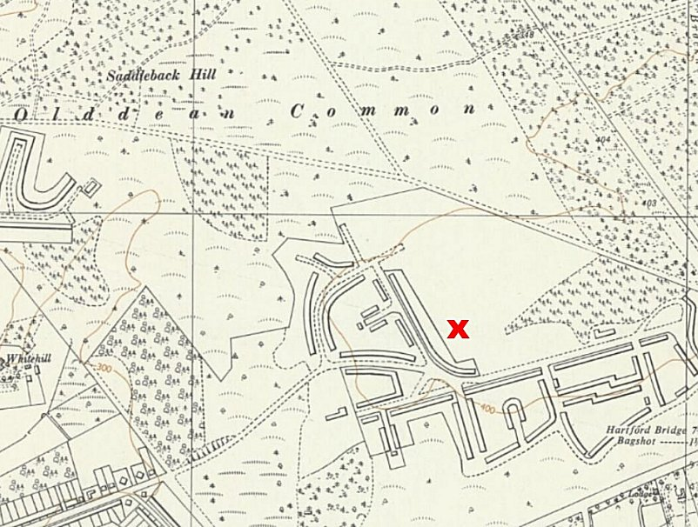
 | Ordnance Survey 1961

