Camp 674 Consols Mine Camp, Par, Cornwall

Prisoner of War Camps (1939 – 1948) - Project report by Roger J.C. Thomas - English Heritage 2003
OS NGR | Sheet | No. | Name & Location | County | Cond’n | Type 1945 | Comments
SX 072 532 | 200 | 674 | Consols Mine Camp, Tywardreath, Par | Cornwall | 4 |  | The Mount Holiday Park.

Location:  Before the camp: Par Consols Mine was a copper mine.  Pow Camp:  After the camp:  See:  https://repatriatedlandscape.org/england/pow-sites-in-the-south-west/pow-camp-674-consols-mine/  Further Information: | 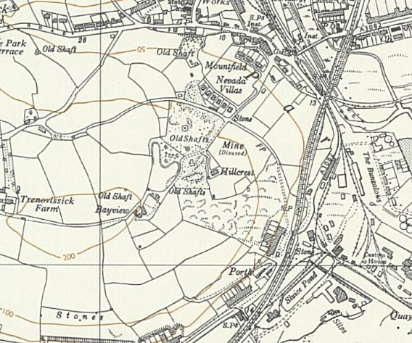
 | Ordnance Survey 1962

