Camp 673 Bridestowe, Okehampton, Devon

Prisoner of War Camps (1939 – 1948) - Project report by Roger J.C. Thomas - English Heritage 2003
OS NGR | Sheet | No. | Name & Location | County | Cond’n | Type 1945 | Comments
SX 514 885 | 191 | 673 | Bridestow, Okehampton | Devon | 4 |  | Woodland

Location: Bridestowe is a village located between Okehampton and Tavistock. The camp was located just S of here in Leawood (Lea Wood).  Before the camp: British troops were brought to Bridestowe and the local area shortly after Dunkirk. A hutted training camp was built at Leawood in fields alongside the road. US troops took over the camp in 1943 until April 1944.  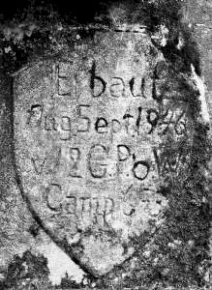  Pow Camp: It is believed that the military camp was converted to a pow compound with a barbed-wire perimeter by Italian pows. The main entrance was opposite Standon Lane.  German pows arrived shortly after D-day.  Memories of beautifully decorated murals inside the huts and wooden models standing by the fence. At Christmas 1944 every child in Bridestowe received a wooden toy made by the pows. (Information from an article by Howard Barkell, March 2015 -  www.bridestowe.org.uk/perch/resources/june15.compressed.pdf.  In the Fox and Hounds Inn at Bridestowe is a mural of a fox hunt painted by German pow Willie Brandt. [HER Number MDV118363].  A bridge was built by German pows in 1946 over the nearby River Tavy. A cement plaque on one of the bridge piers reads – “Erbaut (Built) Aug Sept 1946 [12?] G POW Camp 673”  (finglewoods.org.uk/2019/04/29/the-timber-trail-history-in-the-making/) | 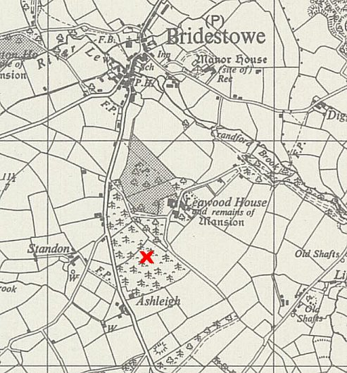
 | Ordnance Survey 1963
After the camp: The huts were sold off and the area planted with conifers.

Further Information:

