Camp 672 Fargo Camp, Larkhill, Wiltshire, Salisbury, Wiltshire

1947 Camp List
672(G.W.Coy) | S | Fargo Camp, Larkhill, Salisbury, Wilts | Durrington Wall, 321 Ext.103 | 80(W.O.) | V/1456/2

Prisoner of War Camps (1939 – 1948) - Project report by Roger J.C. Thomas - English Heritage 2003
OS NGR | Sheet | No. | Name & Location | County | Cond’n | Type 1945 | Comments
SU 107 444 | 184 | 672 | Fargo Camp, Larkhill, Salisbury | Hampshire | 4 | German Working Camp | Site occupied by housing.

Location: Not sure if that is the camp perimeter shown on OS map or the ammunition compound. Near to the very large military camp at Larkhill.  Before the camp:  Pow Camp:  POW mail item identified for December 1946.  After the camp: A Polish resettlement camp was listed for Fargo Camp – but I am not sure if it was on the same site.  Further Information: | 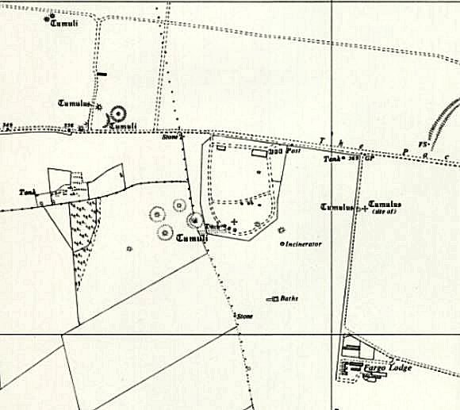
 | Ordnance Survey 1961

