Camp 671 Popham Camp, Micheldever, Winchester, Hampshire

Prisoner of War Camps (1939 – 1948) - Project report by Roger J.C. Thomas - English Heritage 2003
OS NGR | Sheet | No. | Name & Location | County | Cond’n | Type 1945 | Comments
SU 5593 4371 | 185 | 671 | Popham Camp, Micheldever, Winchester | Hampshire | 5 | German  Working Camp | Precise location not identified. NGR for  centre of village.

Location: Martin J Richards (www.systonimages.co.uk/) carried out field research to locate the camp. He has placed it at NGR SU 5229 4358. At this location, the 1961 OS map shows a marked quadrilateral area very similar to other camps where a compound perimeter is marked. The inset map is undated, but published in 1949, and shows various small buildings in the same area.  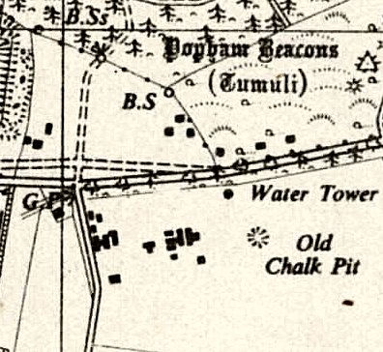  Before the camp:  Pow Camp:  After the camp: 2020 farmland.  Further Information: | 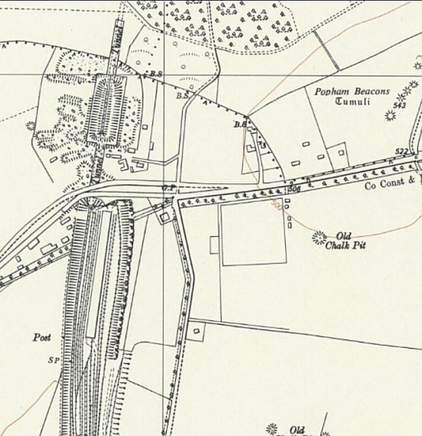
 | Ordnance Survey 1961

There is a National Archive reference (FO 939/322) to Camp 671 Working Camp, Lockerley Camp, Romsey, Hampshire, dated 1945 - 1946. It does not appear in any lists I have seen so far and I think it may have been a sub-camp and so have not given it a separate entry. There was a huge US Army warehouse in Lockerley from 1943 to 1944, this may have been the site used.

