Camp 670b Shaftesbury Camp, Dovercourt, Essex

1947 Camp List
680(G.W.Coy) | E | Shaftesbury Camp, Dovercourt, Essex | Harwich 416 Ext.12 | 71(W.O.) | V/1270/4

Prisoner of War Camps (1939 – 1948) - Project report by Roger J.C. Thomas - English Heritage 2003
OS NGR | Sheet | No. | Name & Location | County | Cond’n | Type 1945 | Comments
TM 2391 3020 | 169 | 670b | Shaftesbury Camp, Dovercourt, Harwich | Essex | 4 |  | Site occupied by housing. See Camp no.680.
TM 244 302 |  | 680 |  |  |  | German Working Company | See 670b

Location: 670b at position x / 680 at position y.  There are details of the Holiday Camp at ‘y’ being used as a pow camp. I have not found details for the position at x near to, or in the Shaftesbury Society camp.  Before the camp: In 1937 Harwich Borough Council bought the land at ‘y’ and leased it to the Dovercourt Bay Holiday Camp and Lido. Known as Warner’s Holiday camp.  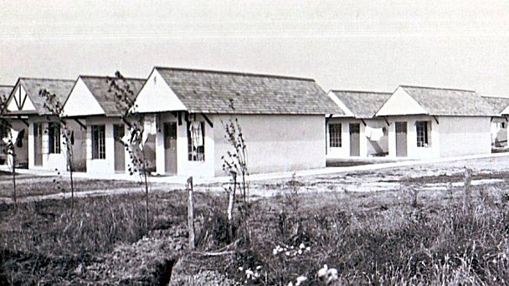  Towards the end of 1938 the camp was used by the Refugee Children’s Movement to accommodate Kindertransport children.  At the start of the war the camp was requisitioned for military use.  Pow Camp: Became a pow camp in 1942.  As part of the re-education programme administered by the Control Office for Germany and Austria (COGA), Paul Bondy, a German-speaking refugee gave lectures at Camp 680 on 4 March 1947. | 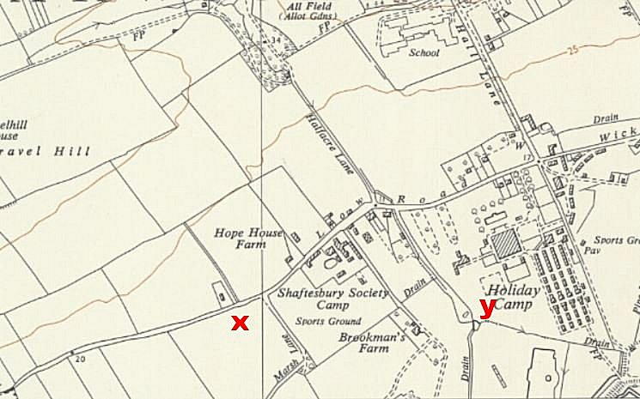
 | Ordnance Survey 1958

After the camp: Re-opened as a holiday camp. Site used for BBC comedy Hi-de-Hi. Closed in 1990 and demolished in 1992. 2020 residential area.

Further Information:

