Camp 669 West Ridge Camp, Greenford, Middlesex

1947 Camp List
669(G.W.Coy) | L.D. | West Ridge Camp, Greenford, Middlesex | Waxlow 2202 Ext.173 | 17(W.O.) | V/1270/4

Prisoner of War Camps (1939 – 1948) - Project report by Roger J.C. Thomas - English Heritage 2003
OS NGR | Sheet | No. | Name & Location | County | Cond’n | Type 1945 | Comments
TQ 1368 8332 | 176 | 669 | West Ridge Camp, Greenford | Middlesex | 4 | German Working Camp | Site occupied by housing.

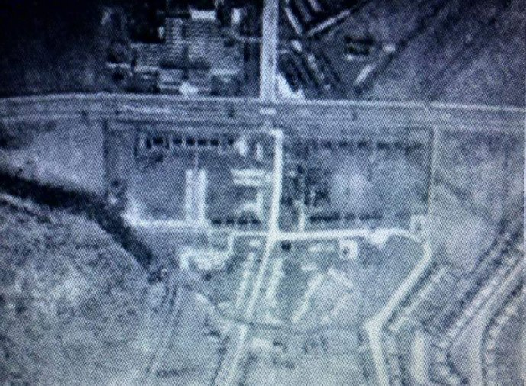  Location: Just S and alongside the A40 running through Greenford, to E of Grand Union Canal, (x marking approximate centre of the camp).  1947 aerial view of the camp >  Before the camp:  Open space. | 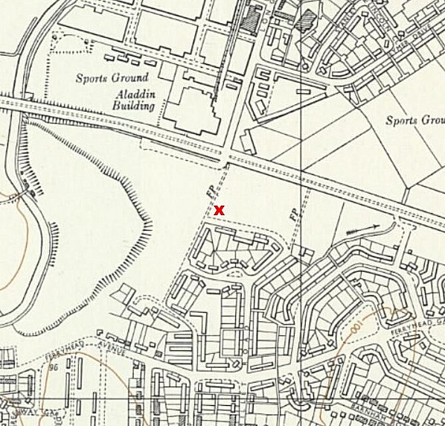
 | Ordnance Survey 1960

Pow Camp: Italian and then German pows remembered. Mainly Nissen huts. POWs worked on local farms – also details of them working on building the Greenford Underground Station.

As part of the re-education programme administered by the Control Office for Germany and Austria (COGA), Paul Bondy, a German-speaking refugee gave a lecture at the camp on 8 December 1946.

The camp was mentioned in the House of Commons through a written response:

Mr J Hudson [MP for Ealing West] asked the Secretary of State for War whether his Department could make use of the hutments at West Ridge Camp, Greenford, for storing records and thus free for temporary housing the hutments in Gunnersbury Park which the Ealing Town Council think are available for that purpose.

Mr Bellenger - No, Sir. I would refer my hon. Friend to the reply I gave him on 29th October. The hutments at Gunnersbury are being used not only for the storage of records but also as an office for over 200 clerks belonging to the Record Office in occupation, and there is no room for either at West Ridge Camp, Greenford, as half of the camp is occupied by prisoners of war and the remainder has already been handed over to the Ministry of Health for temporary housing.
(House of Commons - 3 December 1946 vol 431).

After the camp: Some of the huts were used as emergency accommodation. 2020 residential (Nicholas Close) / park area.

