Camp 667 Byrness Camp, Redesdale, Northumberland (aka Low Byrness)

Prisoner of War Camps (1939 – 1948) - Project report by Roger J.C. Thomas - English Heritage 2003
OS NGR | Sheet | No. | Name & Location | County | Cond’n | Type 1945 | Comments
NT 779 013 | 80 | 667 | Byrness Camp, Redesdale, Otterburn | Northumberland | 2

Location: Remote. About 23km SE of Jedburgh  Before the camp:  Pow Camp:  Reported as having 442 pows in 1946.  After the camp: 2020 camping and caravan site.  Further Information: | 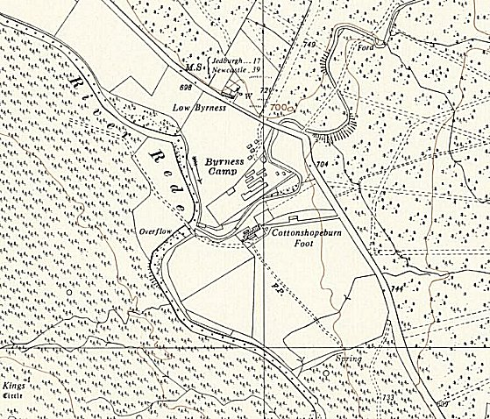
 | Ordnance Survey 1957

