Camp 666 Stoberry Park, Wells, Somerset

1947 Camp List
666(G.W.Coy) | S | Stoberry Park, Wells, Somerset | Wells 424 | 37(W.O.) | V/1270/4

Prisoner of War Camps (1939 – 1948) - Project report by Roger J.C. Thomas - English Heritage 2003
OS NGR | Sheet | No. | Name & Location | County | Cond’n | Type 1945 | Comments
ST 552 463 | 182 | 666 | Stoberry Park, Wells | Somerset | 4 | German Working Camp | Decorative gate posts & statue of Romulus & Remus.

Location: The NGR is for the site shown between College Road and ‘School’ on the map.  Before the camp:  Pow Camp: Italian, then German POWs  The entrance to the camp had two large stone pillars on College Road.  It is believed that the statue of Romulus and Remus was created by an Italian pow at camp 107 Penleigh, however one article also states that he may have been transferred to Stoberry.  After the camp:  Further Information: | 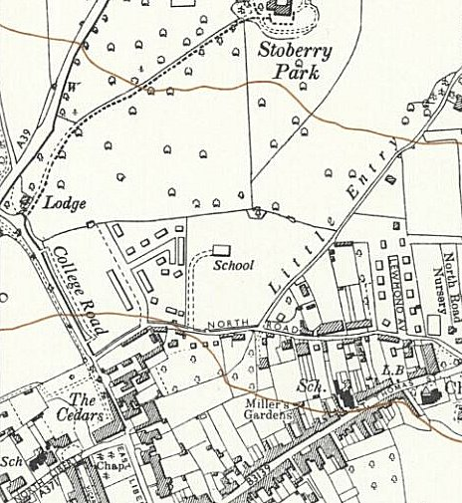
 | Ordnance Survey 1961

