Camp 665 Cross Keys Camp, Norton Fitzwarren, Taunton, Somerset

Prisoner of War Camps (1939 – 1948) - Project report by Roger J.C. Thomas - English Heritage 2003
OS NGR | Sheet | No. | Name & Location | County | Cond’n | Type 1945 | Comments
ST 200 265 | 193 | 665 | Cross Keys Camp, Norton Fitzwarren, Taunton | Somerset | 4 |  | Pre-existing camp serving an ordnance depot. Footprint extant in part.

Location: Named after the nearby Cross Keys Inn, shown towards top right of map, (ST 2045 2636).  Before the camp: Farmland. Depot used by Royal Army Service Corps from 1941, then as US depot G-50 from 1942.  Pow Camp: Pow camp was established for 300 pows in 1941. Italian and then German pows. Mainly Nissen huts. Low risk pows worked in the depot and at local farms.  Norton Fitzwarren Parish Council minutes, 2 October 1944: “ ‘Italian Prisoners of War and Coloured Troops – After a discussion on the dangers of mixed troops being at liberty to roam our streets and fields at will, resolved to wait a while to see what action can be taken by the military, and in the hope that their stay will not be of long duration.’ From this extract it seems the people of Norton Fitzwarren gave black GIs the same respect as enemy prisoners.” (From - Somerset At War – Henry Buckton – Amberley – 2009).  “Aerial photographs taken in 1947 show that the northern part of the camp had been converted to a prisoner of war camp in the latter part of the war. A perimeter fence, with sentry towers at regular intervals, encloses a polygonal area measuring 410m by 415m at its widest parts. It was centred at ST 2004 2640. There appear to have been no new buildings constructed in the interior suggesting it may have been a tented camp. A number of buildings half way along the southern side of the perimeter appear to be the main access point to the camp at ST 2006 2627. The seagull trenches in this area appear to have been filled in by the time of the POW camp and some show on later photographs as cropmarks. Much of the depot buildings remain in use today but the area of the POW camp is now returned to farm land.“  (Somerset HER Record). | 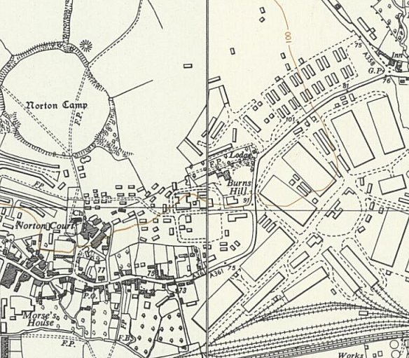
 | Ordnance Survey 1961
After the camp: Used as a British Army depot until the 1960’s. 2020 area shown as mainly farmland with some light industry.

Further Information:

