Camp 661a Eynsham Park, Eynsham, Oxfordshire

Prisoner of War Camps (1939 – 1948) - Project report by Roger J.C. Thomas - English Heritage 2003
OS NGR | Sheet | No. | Name & Location | County | Cond’n | Type 1945 | Comments
SP 395 123 | 164 | 661a | Eynsham Park, Eynsham, North Leigh | Oxfordshire | 5 |  | Site cannot be determined from modern aerial coverage due to tree cover.

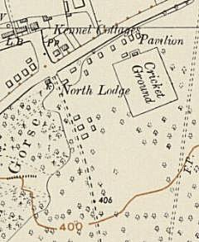  Location: About 4km NE of Witney. The Park is a large area – a 1955 map shows some small buildings along the road and the drive to the Park, but I do not know if these were pow huts.  Before the camp: Large country house and estate. Requisitioned for military use in WW2.  Pow Camp:  After the camp:  Further Information:  ‘Prisoners of England’ by Miriam Kochan has four plates for the camp – a drawing and three photographs.  Archives and Cornish Studies Service have copies of the Camp magazine dated 1946 – Ref ST/503  London Metropolitan Archives have copies of the camp magazine, numbers 5,9-10,13-15,19-20,22-23 – dated 1946 to 1947. Reference LMA/4288/D/04/011 | 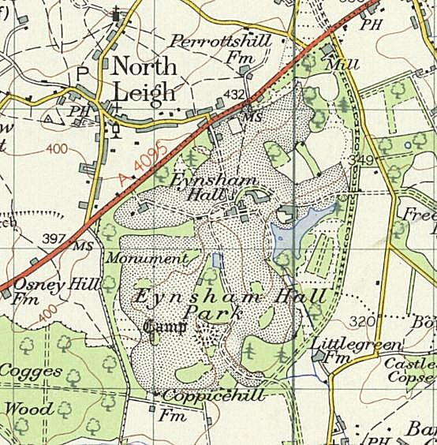
 | Ordnance Survey 1960

