Camp 661 Leffnoll Camp, Cairnryan, Stranraer, Wigtownshire, Scotland

1947 Camp List
661(G.W.Coy) | Sc | Leffnol Camp, Cairnryan, Stranraer, Wigtownshire | Cairnryan 228 Ext.13, Sub Ext 8 | 105(W.O.) | V/1270/4

Prisoner of War Camps (1939 – 1948) - Project report by Roger J.C. Thomas - English Heritage 2003
OS NGR | Sheet | No. | Name & Location | County | Cond’n | Type 1945 | Comments
 |  | 661 | Leffnoll Camp, Cairnryan, Stranraer | Wigtownshire |  |  | Scotland

Location: About 6km NNE of Stranraer. NGR NX 0795 6607  Before the camp: Farmland. Site used to accommodate troops building the Cairnryan Military Railway and working at the Leffnoll railway yard and sidings.  Pow Camp: Mainly Nissen huts. Aerial photographs taken in 1945 show at least 27 huts outside the camp and 73 huts within a fenced area.  Canmore - “The perimeter fence is visible on the air photographs and this shows that the prisoner-of-war camp was a later construction as the fence-line crosses three hut bases on the N side, probably from the earlier accommodation camp. The original camp was built as an accommodation camp for personnel employed on the marshalling yard at Leffnol.”  After the camp:  Further Information:  http://canmore.org.uk/site/90256  Aerial photographs - 106G/Scot/UK 987, 3139-3140, flown 9 November 1945.  Aerial photographs show bases of huts - RCAHMSAP 1992, 1995. | 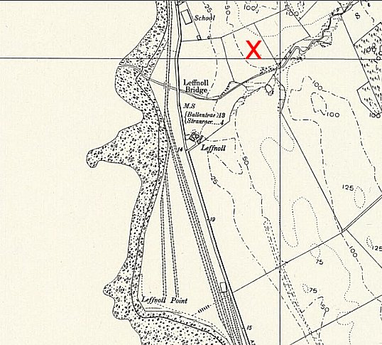
 | Ordnance Survey

