Camp 658 Hill Camp, Westbury, Wiltshire

1947 Camp List
658(G.W.Coy) | S | Hill Camp, Westbury, Wilts | Westbury(Wilts) 273 Ext.12 | 80(W.O.) | V/1270/4

Prisoner of War Camps (1939 – 1948) - Project report by Roger J.C. Thomas - English Heritage 2003
OS NGR | Sheet | No. | Name & Location | County | Cond’n | Type 1945 | Comments
ST 8726 5111 | 183 | 658 | Hill Camp, Westbury | Wiltshire | 5 | German Working Camp | Precise location not identified, NGR given for centre of Westbury.

Location: Hill Camp was on Ham Road in Westbury in a field opposite Ham Cottages (X) at approximate NGR ST 864 525 with the entrance on Ham Road.  Camp 114 Eden Vale was near this site just over 2 km to the S.  Before the camp: Farmland  Pow Camp: Italian and then German pows.  My thanks go to David Jenkins who provided the location for the camp and the following information – “After speaking to several elderly residents who were alive at the time, they told me that the camp had both Italians and Germans in. I’m not sure if it was at one time only the Military did move POW’s around. My view is that the camp had Italians first and then Germans, both of which helped contribute towards local labour i.e. working on farms and repairing roads etc.  With regards to the date the camp was open I’m not exactly sure. It may of been 1943/44 but the date of closure would of been 1947. It gives that date in the National Archives under ref FO 939/186.”  POW mail seen dated November 1946.  After the camp: 2020 residential estate.  Further Information:  National Archives – FO 939/186 – 658 Working Camp, Hill Camp, Westbury, Wiltshire. Dated 1945 – 1947. | 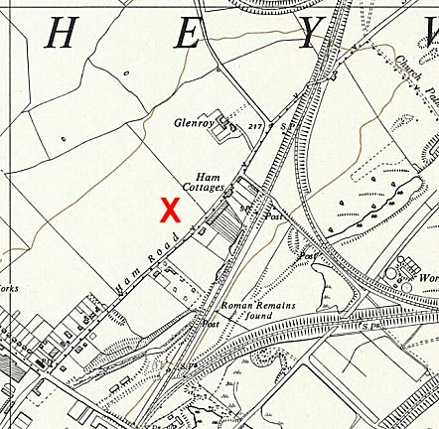
 | Ordnance Survey 1961

