Camp 658 Barn House Farm, Shipley, Surrey

Prisoner of War Camps (1939 – 1948) - Project report by Roger J.C. Thomas - English Heritage 2003
OS NGR | Sheet | No. | Name & Location | County | Cond’n | Type 1945 | Comments
TQ 127 216 | 198 | 658 | Barn House Farm, Shipley, Horsham | Surrey | 4 |  | Advanced Landing Ground (ALG) built prior to D-Day.

Location: 1.5km W of Shipley village.  Before the camp: Farmland. Used to build a temporary airfield (ALG) before D-day. Many had a ‘L’ shape and the map appears to show that pattern next to the farm.  Pow Camp:  After the camp: Reverted to farmland.  Further Information: | 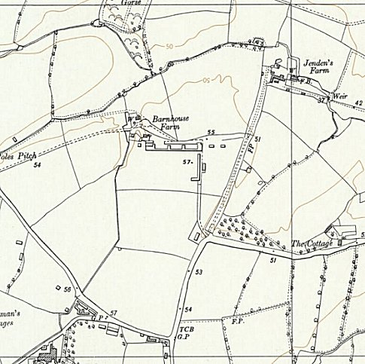
 | Ordnance Survey 1962

