Camp 552 (& 657, 683, 1011) Graven Hill / Arncott Camps, Oxfordshire (aka Bolero Camp)

Included in the 1945 ICRC Camp list – Labour Camp. 552. Bolero Sheds, Craven Hill, Bicester, Oxon.

1947 Camp List
657(G.W.Coy) | S | Shed B 35, Arncott Depot, Bicester, Oxon | Bicester 260 Ext.291 | 52(W.O.) | V/1456/2
683(G.W.Coy) | S | Camp E.30 C.O.D. Bicester, (Postal Address) Shed E.30 Graven Hill, Arncott Depot, Oxford | Bicester 260 Ext.273 | 52(W.O.) | V/1456/2

Prisoner of War Camps (1939 – 1948) - Project report by Roger J.C. Thomas - English Heritage 2003
OS NGR | No. | Name & Location | County | Cond’n | Type 1945 | Comments
SP 5883 2040 | 553 | Bolero Camp, Graven Hill, Bicester | Oxfordshire | 4 | German Working Company | Bolero' was the codename used for any facilities associated with the provision of support of the US Army. Four 'Bolero' complexes existed on Craven Hill - SP 5826 2079 [A] (Romney huts), SP 5850 2064 [B] (dispersed Nissen hut camp), SP 5936 2044 [C] (dispersed Nissen hut camp) and SP 5914 2099 [D] (Romney huts, gun park). NGR given for feature centre of the Craven Hill complex. See Camp no.683.
SP 61 21 | 657 (1) | No.9 Tented Camp, Arncott, Bicester |  | 5
SP 5948 2010 | 657 (2) | Shed D35, Graven Hill, Arncott, Bicester |  | 1 |  | Central Ordnance Depot shed, part of armaments sub-depot
SP 5919 2072 [E] | 683 | Camp E.30, Graven Hill, Arncott, Bicester |  | 3 |  | Central Ordnance Depot shed, group of Romney huts part of the 'Bolero' complexes built for the US Army. See Camp no.553.
SP 5895 1967 [F] | 1011 | Camp D.30 Graven Hill, Arncott, Bicester |  | 4 |  | Central Ordnance Depot.

Location: To the SE of Bicester.  The five camps listed above are all located in a fairly small area as shown on the 1960 OS map left. I have also seen a reference to Camp 600 - Blackthorn Camp, Arncott Depot, Bicester, Oxon – but have not seen ths camp in a list.  The 1955 OS map below shows the site prior to construction of the Depot on the early 1940’s – a later 1966 OS map shows the rail tracks and buildings.  Before the camp: The Graven Hill Depot (Central Ordnance Depot) was a huge military storage area with railway tracks, (Bicester Military Railway). Construction started in 1941 and was largely completed by 1943. There is another storage area at nearby Arncott Hill. The farm ‘Mount Pleasant’ shown on the 1955 OS map was demolished well before the map was published during the construction of the site. Troop accommodation was scattered all round the base of the hill, mainly in Nissen huts. A large part of the site was taken over to store US supplies, (Operation Bolero). | 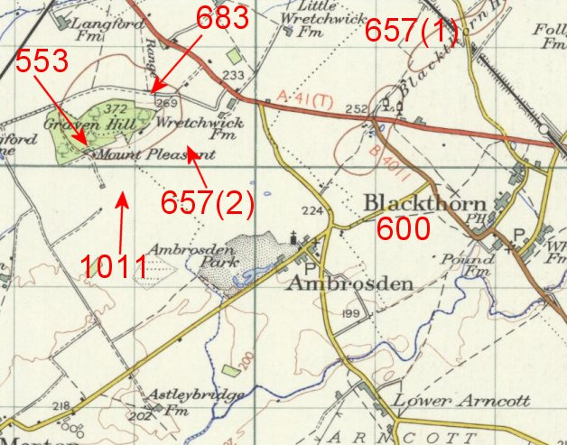

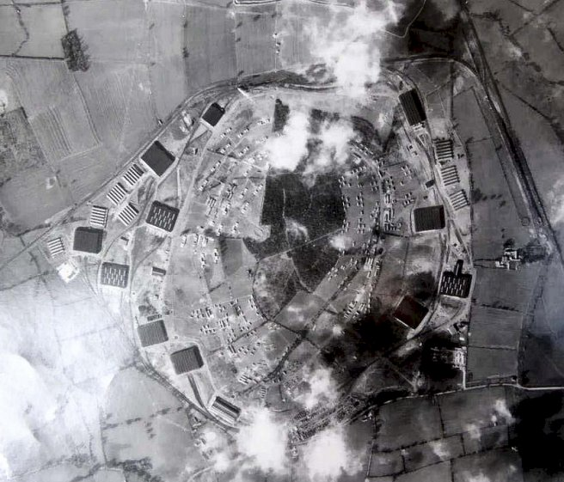 | <  Graven Hill Central Ordnance Depot 1945.  Ordnance Survey issued 1955 with details of the depot omitted  > | 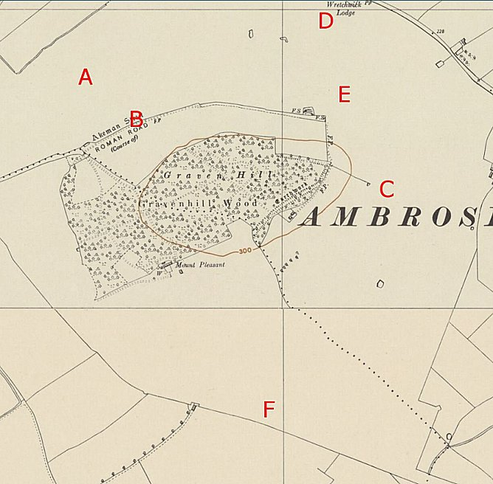

Pow Camps: 550 Italian pows were moved to the site in 1941 to work alongside 1,500 Royal Engineers and 607 Pioneer Corps in building the depot and railway tracks.

Pastscape details for the camps:

“Three groups of Romney huts in the Bolero complex and two groups of accommodation huts were used post-war as Prisoner of War Camps. PoW Camp 657 was located at Bolero group D35, PoW Camp 1011 was located at Bolero group D30, but PoW Camp 553 which was known as ‘Bolero Camp’ was an altogether more complex site; it included Bolero groups E30-E31, the Ordnance Support Unit, together with former Nissen accommodation huts to the south of storage hangar E2, and to the north-west of storage hangar D6.”

There was an International Red Cross inspection of Camp 553 on 22 April 1944 - Italian prisoners, capacity 248.

After the camp:

Further Information:

‘Graven Hill, MOD Bicester, Oxfordshire – Archaeological Building Recording’ – October 2015 - Survey report by Waterman Infrastructure & Environment Ltd

‘The Bicester Military Railway and the Army’s Central Railway Workshops’ – E R Lawton and Major M W Sackett – 1992 – Oxford.

London Metropolitan Archives have a copy of the Camp 657 newspaper (No 2) dated 1946 published by the Anti-National Socialist Working Group. Reference LMA/4288/D/04/010

