Camp 654 (& 1002) Hothfield Common Camp, Nr Ashford, Kent

1947 Camp List
654(G.W.Coy) | E | Hothfield Common Camp, Nr. Ashford, Kent | Ashford 467 | 33(W.O.) | V/1270/4

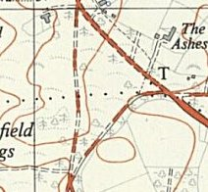  Location: NGR TQ 9728 4573. The 1948 OS map shows many buildings in the area – compared to the 1958 map where the area has been cleared.  Before the camp: The Manor and the Common were requisitioned for use by the army. Nissen huts built 1940 / 1941.  Pow Camp: German working company. 231 huts at this site in 1946.  After the camp: Used as emergency housing and by squatters. Recognised by 1948 as being in very poor condition. Huts demolished mid 1950’s. Marked as a picnic area 2020.  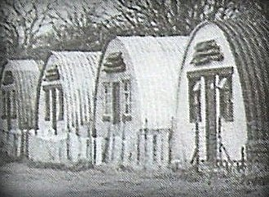  Further Information:  <Nissen huts at Hothfield in use as emergency housing.  Possibly linked to Camp 654A at Wouldham – 32km away. | 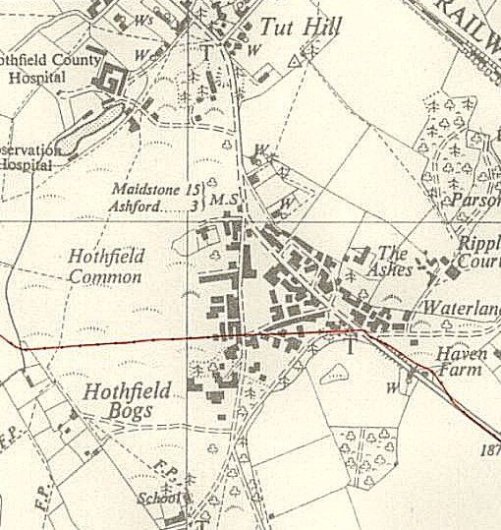
 | Ordnance Survey 1948

