Camp 654A R.E. Bridging Camp, Wouldham, Rochester, Kent

Prisoner of War Camps (1939 – 1948) - Project report by Roger J.C. Thomas - English Heritage 2003
OS NGR | Sheet | No. | Name & Location | County | Cond’n | Type 1945 | Comments
TQ 7123 6527 | 177 | 654a | R.E. Bridging Camp, Wouldham, Rochester | Kent | 4 | German Working Company | Footprint extant.

Location: About 3.5km SW (and across the Medway) from Rochester.  Before the camp: An army bridge building training camp since the 1860’s. Tented camp to begin, but by WW2 largely hutted including ablutions, cookhouse, administration block and Nissen huts.  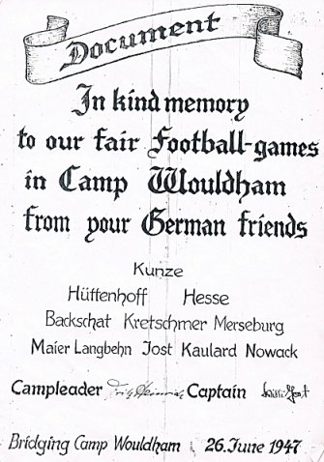  Pow Camp: German pows.  Mail seen dated October 1946 to Germany.  From the picture it shows the camp to be still open in June 1947.  www.wouldhamvillage.com/campandbridge.html  After the camp: 2020 map shows an open site with a few trackways.  Further Information:  Possibly linked to Camp 654 at Hothfield Common – 32km away. | 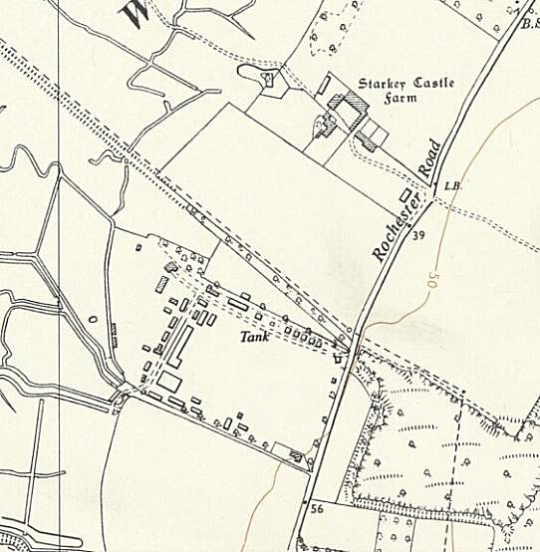
 | Ordnance Survey 1962

