Camp 648 King Harry Ferry Camp, Trelissick, Truro, Devon

ICRC – Labour Camp. 648. King Harry Ferry Camp, Trilissik, Nr Feoch, Truro, Cornwall.

Location: Approximate NGR of W side of the ferry SW 8400 3958  Before the camp: There were many US camps in and around Truro, including at Trelissick House and Gardens. It is possible – but not confirmed – that the pow camp was located in the grounds next to the W ferry point.  Pow Camp: Italian labour camp.  After the camp:  Further Information: | 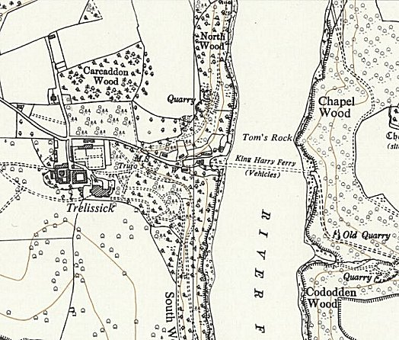
 | Ordnance Survey 1963

