Camp 645 Cruwys Camp, Tiverton, Devonshire

ICRC – Labour Camp. 645. Cruwis Morchard, Tiverton, Devon.

Location: About 8km W of Tiverton. Cruwys Morchard House is at NGR SS 8748 1220  Before the camp:  Pow Camp: Italian labour camp.  After the camp: Private house. Listed building.  Further Information: | 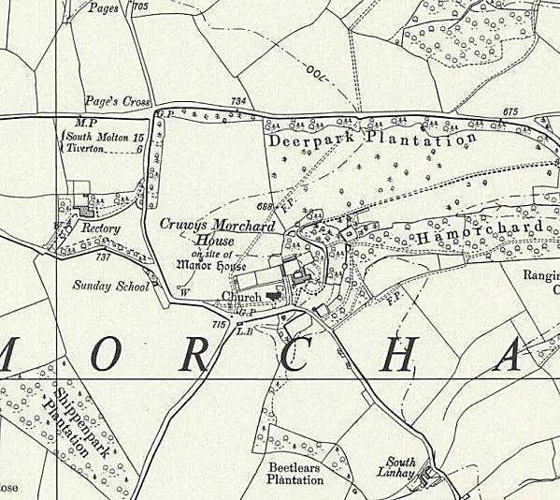
 | Ordnance Survey 1961

