Camp 643 (& 678) H.2 Camp, Lytham St Anne’s, Lancashire

ICRC – Labour Camp. 643. H.2 Camp, Lytham St.Annes, Lancs.

Location: Not sure what ‘H.2’ refers to. The camp was opposite the Shipbuilding Yard at NGR SD 3825 2768. It shows on the 1955 OS map.  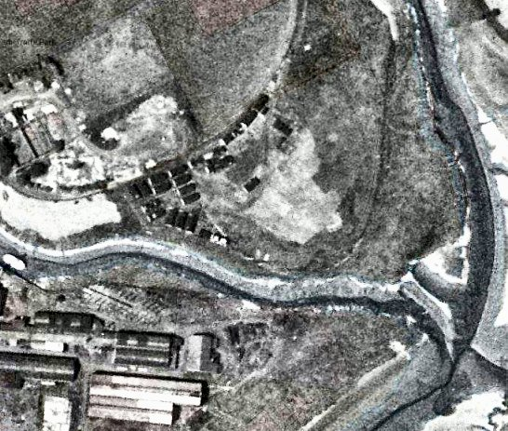  Before the camp: Open space on earlier maps.  Pow Camp: Italian labour camp 643.  With thanks to David Hoyle for providing the location of the camp and pictures at the Archive centre –  www.lythamheritage.co.uk :  “There was indeed an Italian POW camp in Lytham and it was where Stanways Garage is now. The Prisoners were used to build the road to Warton where 20000 American service men were stationed.”  From the aerial photograph the huts appear to be Nissen type. | 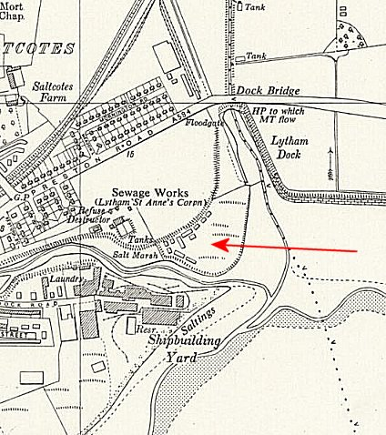
 | Ordnance Survey 1955

From the picture below there was also a Camp 678 at Lytham – for German pows. This may well have been at the same site with change of number occurring, as at many other camps, when the pows changed from Italian to German.
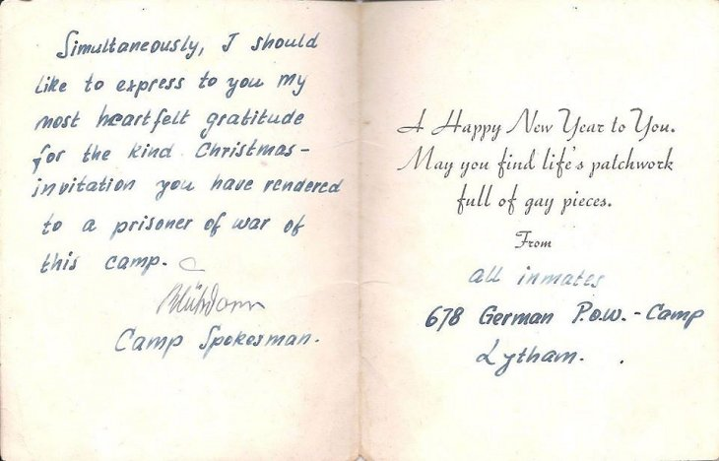
After the camp: 2020 part open space, part Stanways Garage.

Further Information:

National Archives – The camp may be included in: FO 1120/246 – ‘Re-educational survey visit reports for camps 685 to 708’. Between 1946 to 1948 inspections were carried out at various camps for German pows regarding the provision of re-education programmes. The quality and detail of the reports vary greatly.

