Camp 643 Dorfold Hall Camp, Nantwich, Cheshire

Prisoner of War Camps (1939 – 1948) - Project report by Roger J.C. Thomas - English Heritage 2003
OS NGR | Sheet | No. | Name & Location | County | Cond’n | Type 1945 | Comments
SJ 6357 5250 | 118 | 643 | Dorfold Hall Camp, Nantwich | Cheshire | 5 |  | Precise location not identified, NGR for Dorfold Hall

Location: Just to the W of Nantwich  Before the camp: Country house and estate. Wikipedia states that the hall was used to house refugees until November 1940. Used as a camp for US forces.  Pow Camp:  After the camp:  Further Information: | 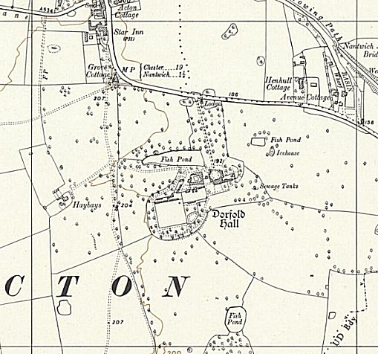
 | Ordnance Survey 1955

