Camp 641 Oswaldkirk, Yorkshire

Included in the 1945 ICRC Camp List – Labour Camp. 641. c/o GPO Oswaldkirk, York

Location: Oswaldkirk is about 6.5km S of Helmsley. NGR SE 623 790. Manor Farm mentioned below is shown opposite the PO next to the pub at approx. NGR SE 6230 7902.  Before the camp: Farmland. At the start of the war Nissen huts were built on Manor Farm Top Field for British military use shortly after Dunkirk. “The foundations of one of the huts can still be seen above ‘The Steps’ beside the church.” * Later troops included the Free Polish Army up to D-Day  Pow Camp: Italian labour camp opened shortly after D-Day. Later, German pows.  “The village next became a prisoner of war camp, except that the Italians had surrendered, and were more like our guests waiting to return home. They fully entered into village life, made skis out of floor boards and taught us to use them on Birch Bank. They also made toys and introduced us to the flavours of the local edible fungi. They also did invaluable work in the farms and gardens of the neighbourhood. One, Eugene Coccimiglio, stayed on, looking after the chickens at the Hall, and another married a nubile village maiden and they went to live in Rome. The Italians were followed by the Germans, some of whom obviously thought that the wrong side had won. One, Herr Wegener, became a strong anglophile, despite what the local bombers had done to his home city of Hamburg. He and his family bought a bungalow in the village in the 1970s.” * | 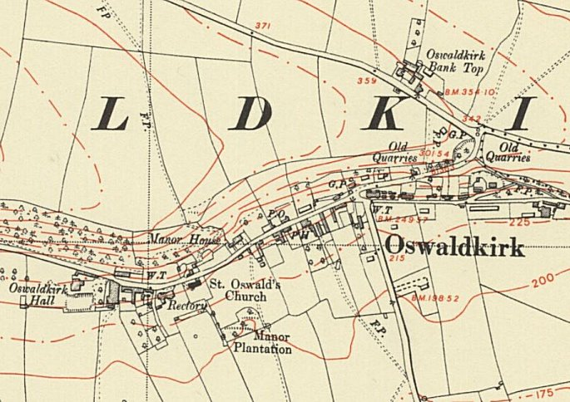
 | Ordnance Survey 1955
After the camp: The area next to the church is now a residential area.
Further Information:
* Two quotes from - Oswaldkirk: A Living Village – Produced by the Oswaldkirk Parish history group – see https://oswaldkirk.net/

