Camp 640 Dodds Camp, Caister, Norfolk

Included in the 1945 ICRC Camp List – Labour Camp. 640. Dodds Camp, Caister, Norfolk.

Location: NGR TG 5190 1328. Dodd’s Camp became known as Caister Holiday Camp.  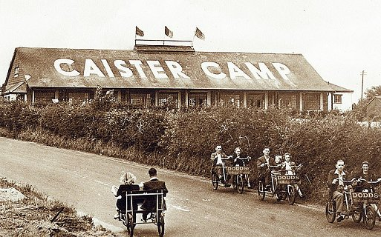  Before the camp: The oldest holiday park in the country. Fletcher Dodd made a small camp for his socialist friends to stay in his garden at Hill House. He expanded this with huts and tents across the road from his house to become a ‘socialist holiday camp’. The camp was requisitioned at the start of the war. Used for a while as a training and transit camp for the military.  <Postcard showing pre-war holiday camp.  Pow Camp: Italian pows. Tents and the holiday huts were used.  The holiday camp is recorded as having re-opened in 1946.  After the camp: Reverted to a holiday camp. 2020 a Haven holiday camp.  Further Information: | 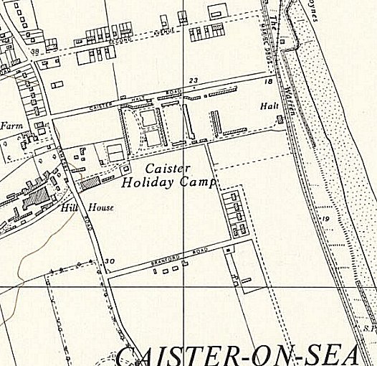
 | Ordnance Survey 1957

