Camp 638 (& 674) Stratton Factory Camp, Swindon, Wiltshire

Included in the 1945 ICRC Camp List – Labour Camp. 638. Kingsdown Hutted camp, Stratton, Swindon, Wilts.

1947 Camp List
674(G.W.Coy) | S | Stratton Factory Camp, Swindon, Wilts | Swindon 3681 Ext.63 | 80(W.O.) | V/1270/4

Prisoner of War Camps (1939 – 1948) - Project report by Roger J.C. Thomas - English Heritage 2003
OS NGR | Sheet | No. | Name & Location | County | Cond’n | Type 1945 | Comments
SU 1703 8720 | 173 | 638 | Stratton Factory Camp, Swindon | Wiltshire | 5 | German Working Company | Precise location not identified. NGR for centre of Stratton St Margaret. See Camp no.638/674.

Location: Powder Works, Stratton - NGR SU 164 864. Kingsdown mentioned in the 1945 list is just to the N of the map.  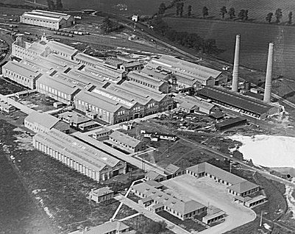  Before the camp: Large factory site built during WW1. Site used by the Pioneer Corps before it became a pow camp.  <Pre-war picture. The two chimneys were demolished at the start of the war as they could have been used for German pilots to navigate.  Pow Camp: Italian and then German pows.  The parish history which records the pow camp at the Stratton powder factory site states; “a pow camp housing first Cypriots then Germans”. (No response regarding Cypriots).  After the camp: 2020 area is Kembrey Park Industrial Trading Estate.  Further Information: | 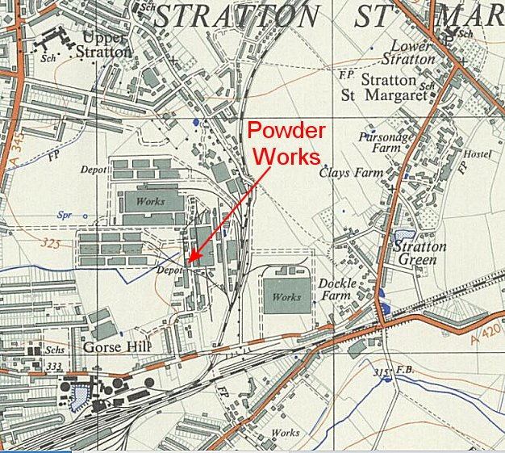
 | Ordnance Survey 1959

