Camp 637 Centenary Road, Goole, Yorkshire

Included in the 1945 ICRC Camp List – Labour Camp. 637. Centenary Road Camp, Goole, Yorks.

Prisoner of War Camps (1939 – 1948) - Project report by Roger J.C. Thomas - English Heritage 2003
OS NGR | Sheet | No. | Name & Location | County | Cond’n | Type 1945 | Comments
SE 740 242 | 150 | 637 | Centenary Road, Goole | Yorkshire | 5 |  | Precise location not identified, NGR given for approx centre of length of Centenary Road

Location: The 1953 OS shows a very likely place – the area was clear on a previous 1938 revised map. Another site was at Coronation Street, Goole, 0.75km away.  Before the camp: Open space.  Pow Camp: Italian and then German pows.  After the camp: 2020 school grounds  Further Information: | 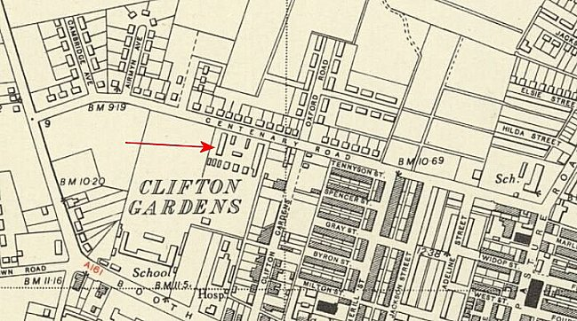
 | Ordnance Survey 1953

