Camp 636 (& 691) Cowick Hall, Snaith, Yorkshire

Included in the 1945 ICRC Camp List – Labour Camp. 636. Cowick Hall, Snaith, Goole, Yorks.

Prisoner of War Camps (1939 – 1948) - Project report by Roger J.C. Thomas - English Heritage 2003
OS NGR | Sheet | No. | Name & Location | County | Cond’n | Type 1945 | Comments
SE 6555 2120 | 105 | 636 | Cowick Hall, West Cowick, Snaith | Yorkshire | 4 |  | Restored parkland. See Camp no.636/691.
 |  | 691 |  |  |  | German working company

Location: Camp shown on map to W of Hall and along the drive.  Before the camp: Country house and estate. The Hall was largely derelict at the start of the war.  Pow Camp: German pows.  After the camp: 2020 headquarters for chemical company Croda International.  Further Information: | 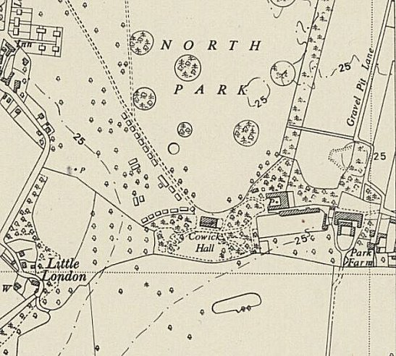
 | Ordnance Survey 1950

