Camp 635 Lord Mayor's Camp, Amble, Northumberland

Prisoner of War Camps (1939 – 1948) - Project report by Roger J.C. Thomas - English Heritage 2003
OS NGR | Sheet | No. | Name & Location | County | Cond’n | Type 1945 | Comments
NU 2733 0427 | 88 | 635 | Lord Mayor's Camp, Amble | Northumberland | 4 |  | Caravan site.

Location: Just to the E of Amble  Before the camp: Field bought by a Lord Mayor of Newcastle for a poor children’s holiday camp. Military use from start of war.  Pow Camp: German pow camp.  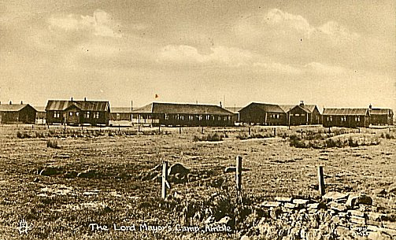  Tuck’s postcard from c1944 | 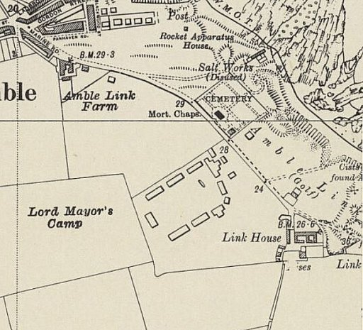
 | Ordnance Survey Revised 1938 / Published 1948

After the camp: Used for a short while to house displaced persons. 2020 open space and residential area.

Further Information:

