Camp 633 (& 656) Boughton Camp, New Ollerton, Nottinghamshire (aka Proteus Camp)

1947 Camp List
633(G.W.Coy) | N | Proteus Camp, Ollerton, Notts | Edwinstowe 79 | 27(W.O.) | V/1456/2

Prisoner of War Camps (1939 – 1948) - Project report by Roger J.C. Thomas - English Heritage 2003
OS NGR | Sheet | No. | Name & Location | County | Cond’n | Type 1945 | Comments
SK 6835 6790 | 120 | 633 | Boughton Camp, New Ollerton | Nottinghamshire | 4 | German Working Company | Former Central Ordnance Depot. Industrial estate. See Camp no.633/656

Going for a Boughton – 3 of them:
Camp 35 - SP 749 664 – In Boughton Park by village of Boughton, Northamptonshire.
Camp 259 - SP 893 818 – Weekley camp in Boughton Park by Boughton House, Northamptonshire.
Camp 633 - SK 6835 679 – New Ollerton, Nottinghamshire (aka Proteus camp).

Location: The site and depot are shown on the 1967 OS map, but not on earlier maps such as the one produced in 1955.  Before the camp:  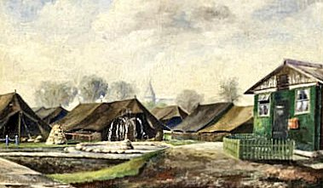  Pow Camp: Mainly tented camp – 12 men to each tent. However, there were also huts at the site.  < Painting by Theo Fries titled ‘Spring in Camp 633’ – signed by the artist in Easter 1946. It shows the administration hut, tents and fountain.  Most of the pows worked at the Royal Army Ordnance Depot a short distance from the camp.  Camp commandant at the time of the film was Major Wren.  A film showing the camp in 1945 / 1946 was shot by Company Quartermaster Sergeant Guy Reckin. Below stills from the film. | 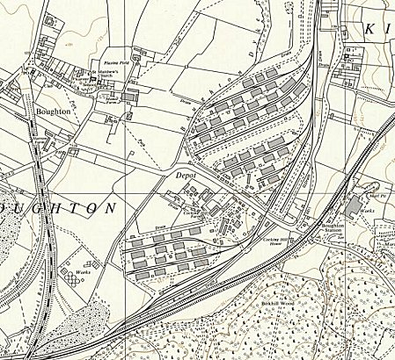
 | Ordnance Survey 1967

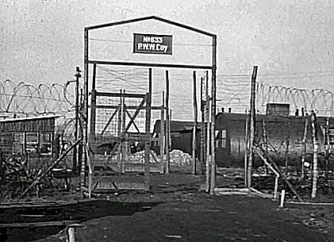 |  | 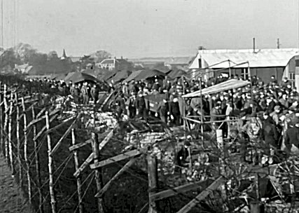
Entrance gate – Nissen huts shown, but references are to the pows living in tents. The huts could have been used for facilities such as offices, ablutions, cookhouses… possibly accommodation for the guards. |  | Barbed wire fencing – possibly small guard tower?
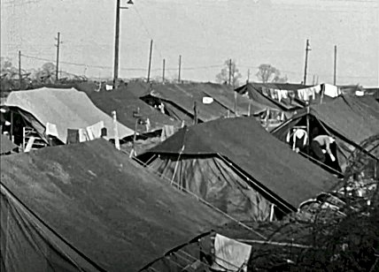 |  | 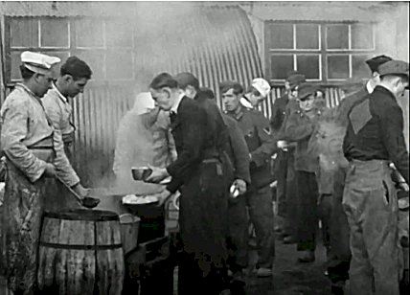
Tents used all-year, accommodating 12 pows. |  | Meal time with large serving containers and barrels.
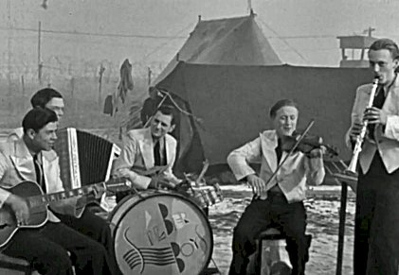 |  | After the camp: 2020 industrial estate.  Further Information:  A copy of the full-length film is held by the IWM, unfortunately it is not available online. The description of the film is worth reading for details of the camp – Catalogue MGH 6698  https://www.iwm.org.uk/collections/item/object/1060035429  A shortened version of the film is available at: https://youtu.be/_b9uoMqNbYU  (Alternative source - https://worklizard.com/lost-films-of-world-war-2/ )  The film of the camp starts at 48m37sec and lasts for about 6 minutes..  The painting by Theo Fries appears at the start of the film and it is held in the IWM Archives. Catalogue EPH 10011
The camp band.

