Camp 631 (& 662, 664) Stadium Camp, Catterick, Yorkshire

1947 Camp List
662(G.W.Coy) | N | Stadium Camp, Catterick Camp, York | Catterick 301 Ext.25 | 36(W.O.) | V/1456/2
664(G.W.Coy) | N | Stadium Camp, Catterick Camp, York | Catterick 301 Ext.25 | 36(W.O.) | V/1456/2
Note: the 2 entries above show exactly the same details except for the camp number – they seem to have been separate sites.

Prisoner of War Camps (1939 – 1948) - Project report by Roger J.C. Thomas - English Heritage 2003
OS NGR | Sheet | No. | Name & Location | County | Cond’n | Type 1945 | Comments
SE 1735 9732 | 99 | 631 | Stadium Camp, Catterick | Yorkshire | 4 | German Working Company | See Camp no.662 & 664.

Location: Catterick is a huge army base, 5km S of Richmond.  Possible location within the camp:  The postcard title shows ‘P.Lines. P.O.W. Catterick’. The camp has different sections called ‘Lines’.  The only ‘P Lines’ I can find was a site called ‘Peronne Lines’ shown on a 1932 map, just below the Military Hospital at SE 184 975 – could this be the location for the pow camp?  Before the camp: Most of the construction was carried out from 1914 to the mid-1930’s.  Pow Camp:  In 1943 the Camp Centre Station, (opened in 1915) was rebuilt using Italian pows. It is not known if these pows were held at Catterick or were transported in for this job.  From shortly after D-day, the camp was used, along with Butterwick Camp 244, to hold Russian pows. They were a very mixed lot. Some had been captured and forced to work under appalling  Postcard – ‘P.Lines, P.O.W. Catterick’  1932 map | 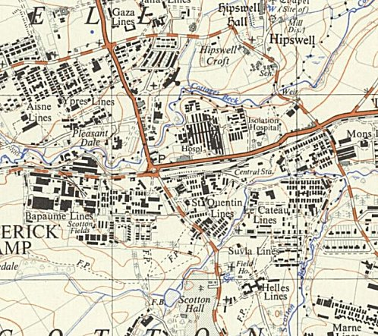
 | Ordnance Survey
conditions with the Todt Organisation. Others had willingly faught alongside the Germans. The Soviet attitude was to regard them all as traitors.

The Camp Commandant gave permission for a Russian Orthodox priest, Father Michael Polsky to visit the camp. The Father gave a service, talked with some of the pows and left musical instruments and books.

In September 1944, Major-General Vasiliev, the new senior representative of the Soviet Military Mission in the UK, stated his intention to visit the two camps. Before doing so complaints were raised by the Soviets about the visit of Father Michael, and no further visits took place. Vasiliev visited Butterwick Camp for two days and received a mixed reception including some hostility – he then moved on to Catterick.

At Catterick the pows did not show any hostility. On seeing the Russian books donated by Father Michael Vasiliev objected and the books were returned.

The Soviet pows were shipped back to the USSR whether they wished for this or not under an agreement that was confirmed at Yalta. There are reports that many were executed and others imprisoned.

As part of the re-education programme administered by the Control Office for Germany and Austria (COGA), Paul Bondy, a German-speaking refugee gave lectures at the main camp, (he listed it as Camp 662/664) and 1 hostel on 15-17 February 1947. He recorded a camp complement of 1,700.

Camp Commandant (September?) 1945 - ? - Major Rollin Holmes. Very young – aged about 26.

“A surprise birthday gift of an engraved lighter signalled the respect German prisoners of war had for Major Rollin Holmes. Rollin Holmes, retired major, treasures it still. "It was the biggest surprise I ever had, the workmanship is extraordinary," he says of the cigarette lighter carved ornately with Big Ben on one side and his initials, RCH, intricately engraved on the other.

His departure from Stadium Camp at Catterick was also marked with a brass plaque - "I still don't know where they got the metal from" - while a few months earlier there'd been a birthday card "from all the German soldiers on the camp"…

"I was pretty strict," insists Mr Holmes, "but I suppose they must have thought I was a decent bloke."

Born in West Hartlepool - "belonged West Hartlepool," he says, in proper parlance - he left school at 15, became a saw mills clerk, joined the Army as a 22-year-old private on August 8, 1940, had risen to sergeant within six months, was commissioned in August 1941 and made major soon after his 24th birthday.

It wasn't so much accelerated promotion as fast approaching the world speed record. No less quick off the mark, the former West Hartlepool rugby club player became Northern Command 440 yards champion, too.

He'd had three years commanding East African troops, learned Swahili, returned to Britain in the week of VE Day and after a month's leave, reported to the orderly room at Stadium Camp on a summer afternoon in 1945….

On arrival; "They told me the outgoing major was on a tour of the camp with the brigadier-general, and when I caught up with them, the general clearly wasn't very happy. He asked who was in charge and the other major pointed and said I was. I thought 'You absolute sh....'."

He tails off gently; probably meant shyster. The general condemnation was deserved, nonetheless. A bit of a mess?

"Oh, a hell of a mess. Everywhere was dirty, the cookhouse absolutely filthy, the discipline fairly bad.

"The general said he'd be back in a few months and if things hadn't improved someone would be for the high jump. You didn't argue with very senior officers. After a rollicking like that, I just resolved to get on with the job."

Stadium Camp held more than 1,000 prisoners - "You couldn't put 1,000 men down like that and expect them just to get on with it" - with another 200 billeted under his overall command at Walworth Castle, near Darlington.

Major Holmes allowed them to build a miniature German castle - a Schloss - at the camp entrance, to have a theatre, a museum and a broadcast relay system.

"We played records in the office which were somehow transmitted all over the camp; I think the Germans appreciated it. They were things that made life a little bit more easy.

"They were only Nissen huts, basic camp beds, no luxuries, but there were always people in prisoner of war camps who could do something special, like the taxidermist who stuffed things for the museum or the chaps who made my lighter.

"Most had been captured early in 1945 and I got the impression were quite pleased to have finished in a warm, comfortable billet rather than fighting in France or the Low Countries."

He left to become Commandant at Walworth Camp 36. (Story from The Northern Echo – 24 March 2005).

After the camp:
Further Information:
National Archives – FO 939/189 - ‘662 and 664 Working Camps, Stadium Camp, Catterick, Yorkshire’. Dated 1946 – 1947.

