Camp 630 Kilverstone Hall, Thetford, Norfolk

Included in the 1945 ICRC Camp List – Labour Camp. 630. Kilverstone Hall, Thetford, Norfolk.

Prisoner of War Camps (1939 – 1948) - Project report by Roger J.C. Thomas - English Heritage 2003
OS NGR | Sheet | No. | Name & Location | County | Cond’n | Type 1945 | Comments
TL 8912 8414 | 144 | 630 | Kilverstone Hall, Thetford | Norfolk | 5 |  | Precise location not identified, NGR given for Kilverstone Hall.

Location:  Before the camp: Country house and estate  Pow Camp: Italian labour camp.  Postal item seen – Letter-sheet in Italian to Messina, Sicily, 13/01/45.  After the camp:  Further Information: | 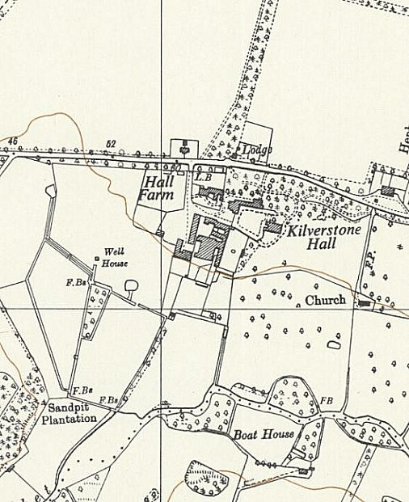
 | Ordnance Survey 1958

