Camp 629 Broom Cottage Camp, Borough Green, Sevenoaks, Kent

Included in the 1945 ICRC Camp List – Labour Camp. 629. Broom Cottage Camp, Borough Green, Sevenoaks, Kent.

Location: About 3.5km away from Borough Green, on Seven Mile Lane. The cottage is at NGR TQ 6417 5584, however the OS map shows a very likely looking site just below. (With thanks to Liz Botterill at Sevenoaks Museum who helped me locate the site).  Before the camp: Part of Mereworth Woods.  Pow Camp: The ICRC listing is for an Italian pow labour camp.  After the camp:  Further Information:  Probably linked to Camp 629 Mabledon Park, Tonbridge, Kent? | 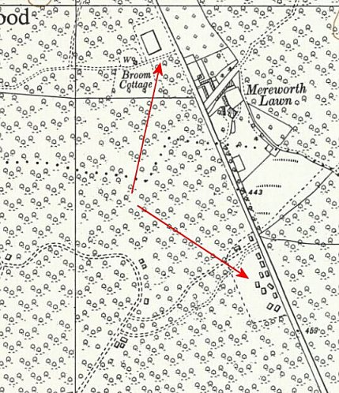
 | Ordnance Survey 1957

