Camp 628 Sutton Park Camp, Potton, Bedfordshire

Included in the 1945 ICRC Camp List – Labour Camp. 628. Address non communiqué.

Prisoner of War Camps (1939 – 1948) - Project report by Roger J.C. Thomas - English Heritage 2003
OS NGR | Sheet | No. | Name & Location | County | Cond’n | Type 1945 | Comments
TL 220 490 | 153 | 628 | Hutted Camp, Sutton Park, Potton | Bedfordshire | 4 |  | Precise location not identified, NGR given for Sutton Park Club House. Golf course.

Location: Just S of Potton, off the Biggleswade Road on the edge of Sutton Park. The golf course is a little further S. NGR TL 2190 4840.  Before the camp: Land belonging to Sutton Park Estate.  Pow Camp: Italian labour camp.  After the camp: As this camp was closing, another camp for German pows was placed nearby at Mansion Potton – Camp 269, about 1.5 km away.  Further Information: | 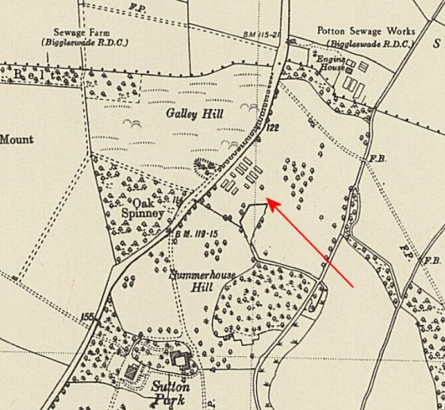
 | Ordnance Survey 1950

