Camp 625 Mistley AA Camp, Mistley, Manningtree, Essex

Included in the 1945 ICRC Camp List – Labour Camp. 625. Mistley A.A. Camp, Manningtree, Essex.

Location: Mistley is located to the E of Manningtree. The most likely location of Furze Hill is in the centre of the map at NGR TM 120 311  Before the camp:  Pow Camp: Italian labour camp. Probably located in the huts vacated by the anti-aircraft battery.  Information from Philip Cunningham - Manningtree Museum and Local History Group; “I assume the AA site with search light was on the same site at Furze Hill. The bunker has all now been built around.  There are still bases of Nissen huts in the woods, apparently near the oak tree known as old knobbly. I assume these were for the POWs and later used to house the homeless.  The Army clearly built several Nissen huts just into the wood and on fairly hilly terrain. This may well have been to house those manning the AA battery.  One of our museum members thinks that the POW’s were actually accommodated in Brunswick House, by the entrance to Furze Hill and Bunker site. [Indicated by arrow] This was originally built as a school, but later taken over as an Asylum.  The story is that the first Italian POWs settled in without problem, but later replaced by Germans who had much tighter controls imposed. There are tales about the Italians locally helping out and playing sports.”  It is possible that Brunswick House, which was closed during the war, was used as offices and for officers – but this is a guess based on what happened at similar sites.  After the camp:  Further Information: | 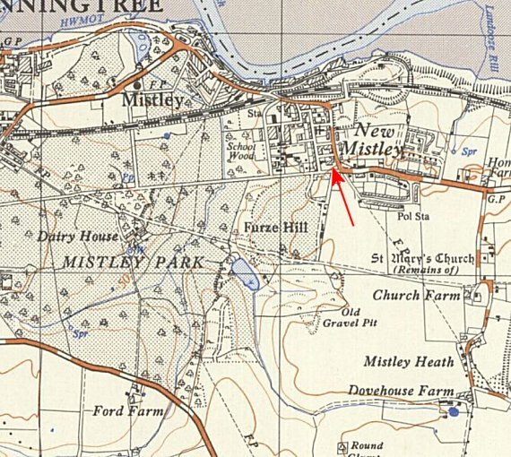
 | Ordnance Survey 1955

In 1951 the Mistley Anti Aircraft Operations Room was built for the Royal Artillery. This was located at Mistley Heath in the SE corner of the map at TM 122 313. I do not know if this was related to the WW2 AA site.

