Camp 624 Shiphay Hutments, Torquay, Devon

Included in the 1945 ICRC Camp List – Labour Camp. 624. Shiphay Hutments, Torquay, Devon.

Location: Shiphay is a district in the north of Torquay. The location of the camp was identified in ‘Shiphay At War’ by Roger Hill (Xlibris, 2006) as being in open fields between Shiphay Avenue and Shiphay Lane. NGR for the centre of the fields SX 8951 6540.  Before the camp: The huts were used by the Prudential before it moved back to London in 1943. The site was then used as the base for the US 237th and 238th Engineering Battalion within D-Day Marshalling Area Camp K3.  Pow Camp: Italian labour camp.  After the camp:  Further Information: | 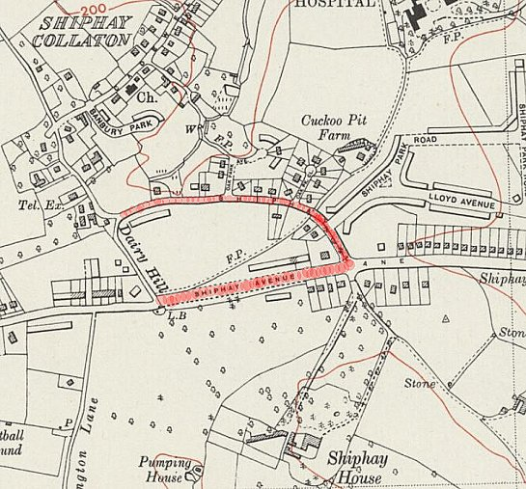
 | Ordnance Survey 1938

