Camp 624 Ossemsley Manor, New Milton, Hampshire

Prisoner of War Camps (1939 – 1948) - Project report by Roger J.C. Thomas - English Heritage 2003
OS NGR | Sheet | No. | Name & Location | County | Cond’n | Type 1945 | Comments
SZ 227 969 | 195 | 624 | Ossemsley Manor, Ossemsley, New Milton | Hampshire | 5 |  | Precise location not identified, NGR given for Ossemsley Manor.

Location: Ossemsley is a small village about 2.5 km N of New Milton. The Manor was at NGR SZ 2269 9691 - however the camp was likely to have been in the grounds, rather than in the house.  Before the camp: Large manor house. Military camp up to D-day when the camp was described as being mainly tented with some Nissen huts surrounded by barbed wire.  Pow Camp:  After the camp: 2020 the house has been subdivided into flats.  Further Information: | 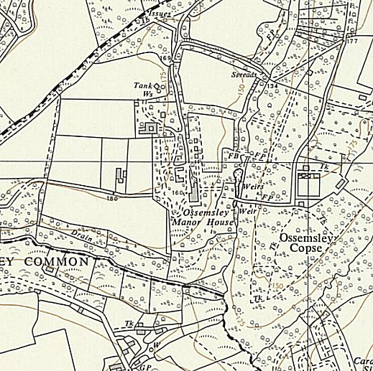
 | Ordnance Survey

