Camp 623 C Hutted Camp, RAC Range, Warcop, Penrith, Cumberland

Included in the 1945 ICRC Camp List – Labour Camp. 623. “C” Hutted Camp, R.A.C. Range, Worcop, Penrith, Cumberland.

Location: The Warcop Training Area and ranges cover a wide area. I am guessing that the pow camp was located amongst the huts shown on the map (NY 7485 1585), probably in huts used by the Royal Armoured Corps up to D-day.  Before the camp: Military camp established in 1942 as a tank gunnery range.  Pow Camp:  Postal item seen – letter from Italy to the camp in 1945.  After the camp:  Further Information: | 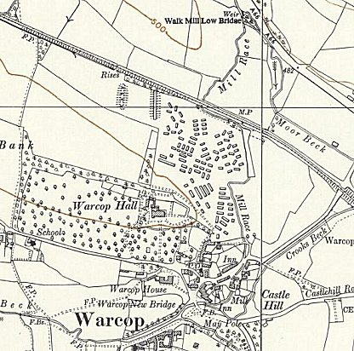
 | Ordnance Survey 1956

