Camp 621 Lower Wanborough, Swindon, Wiltshire

Included in the 1945 ICRC Camp List – Labour Camp. 621. Lower Wanborough, Swindon, Wiltshire.

Location: Lower Wanborough is on the E edge of Swindon. SU 2096 8318 is centre of present area.  Before the camp:  Pow Camp:  After the camp:  Further Information:  Possibly linked to another Camp 621 in Wiltshire - Hartigan's Training Stables, Ogbourne Maizey, Nr Marlborough, Wiltshire | 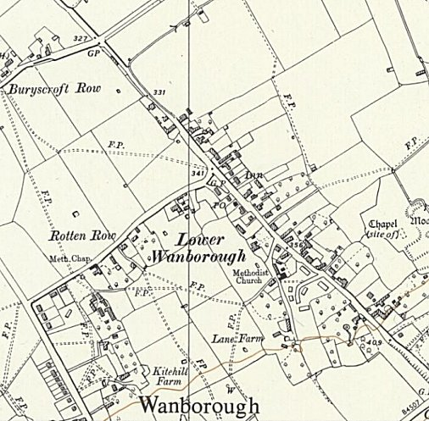
 | Ordnance Survey 1960

