Camp 621 Hartigan's Training Stables, Ogbourne Maizey, Nr Marlborough, Wiltshire

Location: NGR for pow huts SU 1845 7135. Ogbourne Maizey is about 2.5km N of Marlborough.  Before the camp: The stables were owned by Martin Hartigan. They were closed down and the horses dispersed at the start of WW2; the stables were then mainly used for stores. The area was used by the military. There is a reference by Peter Willetts in his book, ‘Armoured Horseman’, of being stationed for a short time at Ogbourne Maizey in 1941 with a squadron of The Queen’s Bays (2nd Dragoon Guards) – probably in one of the two buildings for officers shown on the map. Later, US troops were stationed in the area. In a book about the US Third Army in Britain during WW2, there is a brief mention of Ogbourne Maizey – “The officers were billeted at the Ailesbury Arms Hotel on High Street in Marlborough, while our commanding general and the chief of staff lived in an elegant house called Ogbourne Maizey Manor.” (‘The Ghost in General Patton’s Third Army’ – Eugene G Schulz – 2012 – Xlibris). However, Patton also had rooms at his HQ in Lackham Manor, near to Lacock Village. US troops were accommodated in tents and probably in huts at the site that later became the pow camp.  Pow Camp: The size of the camp would indicate that it was probably a satellite to a larger camp.  Information received from Bruce Fox, Chairman of the Ogbourne St Andrew History Group: “There was indeed a WW2 PoW “camp” at the stables – two army huts behind the “Upper Yard”. It housed Italian PoW’s who were employed on the farms in the surrounding area – they also apparently laid piped water to the hamlet from the estate water tank. They also planted several of the stands of trees around the village. It is unfortunate that the huts were torn down before anyone recorded the names and graffiti inscribed on them – times then were different!”  [There are many cases of water and sewage works being carried out by pows, not just to the camps, but also extending to local villages. This work was usually carried out under the supervision of the Pioneer Corps].  After the camp: Returned to being a stables.  Further Information: | 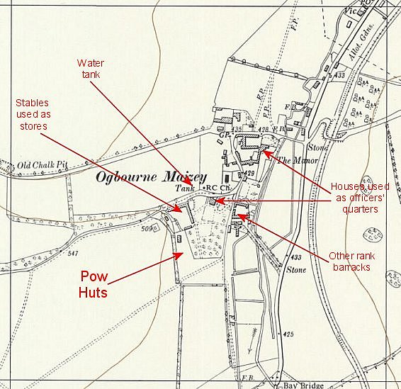
 | Ordnance Survey 1960

Possibly linked to Camp 621 Lower Wanborough, also in Wiltshire.

